***Name:***

***Date:***

***Human Ecology Comprehensive Exam***

***Florida’s Phosphate Risk***

**Instructions:**

1. Read and study all of the assigned materials below under the heading of “Overview.”
2. Use this Word version of the comprehensive exam and put your name and the date in the top left.
3. Go to the questions below and after each answer type out your answers being sure to cite and reference as needed in APA format.
4. Return this exam via Canvas email to the instructor by no later than April 27 at 5 pm.

Note: You can also view this exam as a web page at but the exam questions themselves along with your name and date on the exam must be submitted as a Word document on Canvas email.

**Overview:**

# One of the oldest and least discussed of Florida’s environmental problems involves the phosphate industry that that mined thousands of acres of land in north and central Florida. Your comprehensive exam requires you to first familiarize yourself with this industry and its benefits and risks. I underscore “benefits” because it is an industry that provides value as well as harm and I expect you to thoroughly understand and appreciate both characteristics of the phosphate industry. To that end I ask that you begin by going to the website “[Our Phosphate Risk](http://www.thephosphaterisk.com/)” and thoroughly explore every link you find under the heading “[Phosphate 101](http://www.thephosphaterisk.com/phosphate).” You will particularly need to learn more about the history of the phosphate industry in Florida and the “process” by which phosphate is mined and processed. To that end ho to “[The Phosphate Primer](http://www.fipr.state.fl.us/about-us/phosphate-primer/)” and read all six chapters (they are quite short). You ought to also look at the article “[Florida Counties Try to Contain Phosphate Mines](http://www.nytimes.com/2007/08/04/us/04phosphates.html)” to see how some Florida counties are struggling with this industry.

Having become familiar with the phosphate industry in Florida I now want you to focus upon the environmental harms associated with the industry in the state by reading a case study summary about the [U.S. Army Corps of Engineers efforts to assess the impacts of phosphate mining](http://www.eenews.net/stories/1059947830/print) in Florida.

**Comprehensive Exam Questions:**

Given this background consider the case presented about the value of phosphate and how it has become a dangerously depleted resource by reading the following case analysis: “[Phosphate: A Critical Resource Misused and Now Running Low](http://e360.yale.edu/features/phosphate_a_critical_resource_misused_and_now_running_out)” (also printed at the bottom of this exam).

Thus prepared, I ask you to answer the following questions:

1. Given the value and risks associated with phosphate fertilizer production and use how might a pragmatist approach the environmental issues associated with phosphate fertilizers in such a way that food production is maintained while environmental risks are minimized?
2. Now assume you are a preservationist in your philosophical orientation. How would you respond to the 2011 analysis by [Pearce](http://e360.yale.edu/features/phosphate_a_critical_resource_misused_and_now_running_out) on the issue of depleted phosphate reserves and explain why you respond in the way you do.

# Put yourself in a local community such as [Mulberry Florida](http://www.gosur.com/driving-directions/united-states_florida_mulberry/). Mulberry Florida has just been the site of a [giant sinkhole](http://www.tampabay.com/news/environment/water/gov-rick-scott-tours-mosaic-sinkhole-company-says-hole-is-bigger-deeper/2295417) that dumped millions of gallons of polluted water into their freshwater aquifer. Consider how that sinkhole happened (see article below “[How a massive sinkhole dumped 200 million gallons of radioactive water into a Florida aquifer](https://www.extremetech.com/extreme/236163-how-a-massive-sinkhole-dumped-200-million-gallons-of-radioactive-water-into-a-florida-aquifer)”) From that perspective, and given the fact that the phosphate industry is the number 1 employer in Polk County Florida where Mulberry is situated, tell me how you think the following citizens might approach this disaster recognizing both economic and environmental ramifications to this event. Put yourself in each role and write a 150-200 word position statement each community member might take regarding this crisis:

# County Commissioner

# Local retail business person

# Phosphate worker

# Real estate developer

# Environmental advocate

# School teacher

# Phosphate: A Critical Resource Misused and Now Running Low

Phosphate has been essential to feeding the world since the Green Revolution, but its excessive use as a fertilizer has led to widespread pollution and eutrophication. Now, many of the world’s remaining reserves are starting to be depleted.

By [Fred Pearce](http://e360.yale.edu/authors/fred-pearce) • July 7, 2011

If you wanted to really mess with the world’s food production, a good place to start would be Bou Craa, located in the desert miles from anywhere in the Western Sahara. They don’t grow much here, but Bou Craa is a mine containing one of the world’s largest reserves of phosphate rock. Most of us, most days, will eat some food grown on fields fertilized by phosphate rock from this mine. And there is no substitute.  
  
The Western Sahara is an occupied territory. In 1976, when Spanish colonialists left, its neighbor Morocco invaded, and has held it ever since. Most observers believe the vast phosphate deposits were the major reason that Morocco took an interest. Whatever the truth, the Polisario Front, a rebel movement the UN recognizes as the rightful representatives of the territory, would like it back.  
  
Not many people would call phosphate a critical issue or one with serious environmental consequences. But even leaving aside the resource politics of the Sahara, it is an absolutely vital resource for feeding the world. It is also a resource that could start running low within a couple of decades — and one we grossly misuse, pouring it across the planet and recycling virtually none of it.

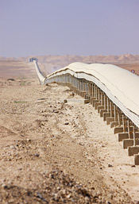

Photo by Ed Darack

The Bou Craa mine in the Western Sahara sends phosphate down a 150-kilometer-long conveyor belt to the port of El Ayoun.

The world’s food supplies are alarmingly dependent on the phosphate fertilizer that is hewn from the desert of the Western Sahara. The vast open-cast mine at Bou Craa delivers several million tons of phosphate rock every year down a 150-kilometer-long conveyor belt, the world’s longest, to the Atlantic port of El Ayoun. From there, it is distributed around the world and made into fertilizer.  
  
Morocco’s phosphate reserves are owned by the [Office Cherifien des Phosphates](http://www.ocpgroup.ma/), a Moroccan state agency. Given the almost unlimited executive powers of the Moroccan monarch, it might reasonably be said that most of the world’s known reserves of phosphate are, in effect, owned by King Mohammed VI and his Alaouite dynasty, which has reigned in Morocco since the 17th century.  
  
If the people of Western Sahara ever resume their war to get their country back — or if the Arab Spring spreads and Morocco goes the way of Libya — then we may be adding phosphate fertilizer to the list of finite resources, such as water and land, that are constraining world food supplies sooner than we think.  
  
Phosphorus is one of the building blocks of all life. Every living cell requires it. Plants need phosphorus to grow as much as they need water. Many soils do not have enough to meet the voracious demands for phosphorus of the high-yielding crop varieties of the Green Revolution. But we can provide more by mining phosphate rock and turning it into fertilizer to spread on the land.  
  
It takes one ton of phosphate to produce every 130 tons of grain, which is why the world mines about 170 million tons of phosphate rock every year to ship around the world and keep soils fertile.  
  
Currently, only about 15 percent of that comes from mines in the Western Sahara and Morocco. But the only other large producers, the U. S. and China, mostly keep supplies for their own use. So Morocco is by far the biggest contributor to international trade, with more than half the total business. The people of India, the world’s largest importer, would be

Most of the world’s best phosphate reserves are gone, and those that remain are in just a handful of countries.

starving without Morocco’s phosphates. Brazil’s agricultural boom would never have happened otherwise.  
  
Even more critically in the longer term, the U.S. Geological Survey says that of the 65 billion tons of the world’s known phosphate rock reserves — and the estimated 16 billion tons that might be economic to mine — almost 80 percent is in Western Sahara and Morocco. Add in China’s reserves, and the figure rises to almost 90 percent. The U.S., with 1.4 billion tons, is close to running out. You can see why agronomists are starting to get worried.  
  
The world is not about to run out of phosphate. But demand is rising, most of the best reserves are gone, and those that remain are in just a handful of countries. Dana Cordell of Linkoping University in Sweden, who runs an academic group called the [Global Phosphorus Research Initiative](http://phosphorusfutures.net/), says we could hit “peak phosphorus” production by around 2030.  
  
As domestic production wanes, the U.S. is starting to join those countries — most of the world, in fact — that import phosphate from Morocco and the Western Sahara. American imports cross the Atlantic courtesy of Potash Corp, the Canada-based fertilizer company whose hostile takeover bid by the Australian mining giant BHP Billiton was blocked by the Canadian government last year. And phosphate mining in Florida, which is home to the world’s largest phosphate mine, is being challenged by environmentalists concerned about its impact on waterways and drinking water supplies.  
  
Already, like other key commodities with once-dominant sources running low, the price of phosphate is starting to yo-yo alarmingly. Prices spiked at an 800-percent increase in 2008.  
  
A century ago, much of the world’s internationally traded phosphate came from bones (a major English import at one time) and guano, excavated from Pacific islands where birds had been defecating phosphate for millions of years. But bones are not traded much any more, and most of the guano islands are now mined out. The island state of Nauru, for instance, is nothing more than a moonscape after decades of mining it to fertilize the grain fields of Australia.  
  
The other key ingredient [needed to fertilize modern high-productivity farm soils is nitrogen](http://e360.yale.edu/features/the_nitrogen_fix_breaking_a_costly_addiction). We know how to “fix” nitrogen from the atmosphere. If the German chemist Fritz Haber hadn’t come up with his process in 1908, there wouldn’t have been a Green Revolution — and there wouldn’t be 7 billion people on the planet today. The nitrogen produced by this process is estimated to be directly responsible for feeding 3 billion of us.  
  
But there are no new sources of phosphate. We continue to mine the rock — or we starve.  
  
Phosphate strip mines are environment wreckers. They produce around 150 million tons of toxic spoil a year. Their massive draglines, huge slurry pipes, and mountainous spoil heaps dominate the landscape for tens of miles in key mining zones, whether in the North African desert or in

Can we find ways to recycle phosphate and keep it in the food chain where we need it?

Florida, a state that still provides three-quarters of American farmers’ phosphate needs.  
  
The world’s largest mine is at Four Corners in an area known as Bone Valley in central Florida. The Four Corners mine covers 58,000 acres, an area five times the size of Manhattan. It is owned by [Mosaic](http://www.mosaicco.com/), a company recently spun off from agribusiness giant Cargill. Next door is the world’s second-largest mine, South Fort Meade. But South Fort Meade is living on borrowed time — its expansion plans are being opposed by local groups, and unless it can expand, the mine will have to close.  
  
As the drag mines move south in Florida, anger has been growing about the environmental impacts. A million tons of mine waste, containing lows levels of radioactivity, are already piled up at dump sites around the state, and disputes are growing over promised mine cleanups. Rivers have dried up, and settling ponds have leaked.  
  
Last year, the local chapter of the Sierra Club went to court to block Mosaic’s plans to extend the life of the South Fort Meade mine by expanding its footprint. The group is concerned about the fate of the Peace River, a vital source of Florida’s drinking water; it says the U.S. Army Corps of Engineers gave approval for the expansion without first conducting a full environmental audit. The case is unresolved to date.  
  
As for the impending shortages of phosphate, will technological advances and market forces solve the problem? We certainly waste a lot of this most valuable resource. Globally, we allow some 37 million tons of phosphorus to spill into the environment each year. It mostly flows down sewers and agricultural drains into rivers and lakes, where it feeds the growth of toxic cyanobacteria and consumes oxygen, creating eutrophication and “dead zones.”

**MORE FROM YALE e360**

[**The Nitrogen Fix: Breaking a Costly Addiction**](http://e360.yale.edu/features/the_nitrogen_fix_breaking_a_costly_addiction)

While nitrogen pollution tends to get top billing as a cause of eutrophication, cyanobacteria can often abstract nitrogen from the air. David Schindler, of the University of Alberta in Edmonton, and others have argued that [limiting phosphorus pollution is the key to eliminating eutrophication](http://www.rso.ualberta.ca/news.cfm?story=81511).  
  
So how can we stop phosphate pollution, recycle it, and keep it in the food chain where we need it? Composting crop residues would be a good way of recycling this valued nutrient back into the soil, cutting the need for new applications of fertilizer — so would capturing some of the 3 million tons of phosphorus that cycles through human bodies annually, after being consumed in our food. Cordell says we should give top priority to recycling our urine, which contains more than half of all the phosphorus that we excrete.  
  
But another conventional technical fix for a resource in short supply — finding a substitute — is not available. Presently, there simply are no substitutes for phosphorus.

**Fred Pearce** is a freelance author and journalist based in the U.K. He is a contributing writer for Yale Environment 360 and is the author of numerous books, including The Land Grabbers, Earth Then and Now: Potent Visual Evidence of Our Changing World, and The Climate Files: The Battle for the Truth About Global Warming.

# [How a massive sinkhole dumped 200 million gallons of radioactive water into a Florida aquifer](https://www.extremetech.com/extreme/236163-how-a-massive-sinkhole-dumped-200-million-gallons-of-radioactive-water-into-a-florida-aquifer)

* By [Joel Hruska](https://www.extremetech.com/author/jhruska) on September 23, 2016 at 9:19 am

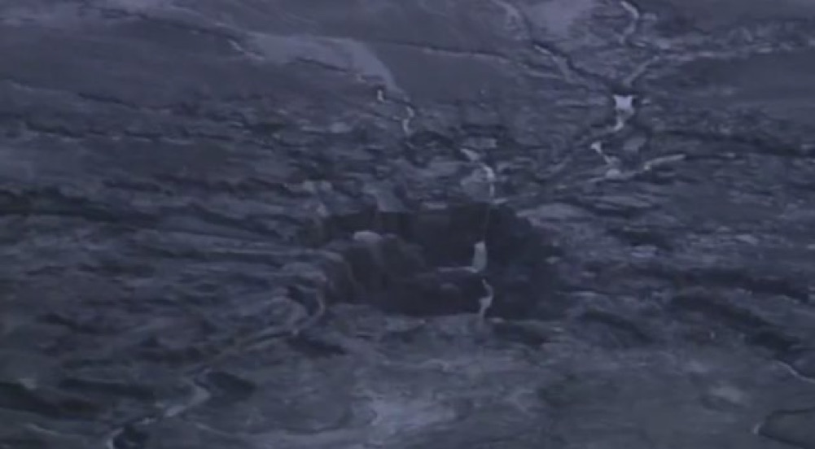

Last month, a 300-foot deep sinkhole opened up at a phosphate plant in Mulberry, Florida. The sinkhole, which measures some 45 feet in diameter, poured 215 million gallons of wastewater directly into a major Florida aquifer. But homeowners and nearby residents who draw drinking water from that aquifer weren’t notified of the breach for more than three weeks.

The reason? Current laws don’t require notification until there is evidence that the water migrated off-site. The manufacturer, Mosaic, told the Florida Department of Environmental Protection, the [EPA](http://www.extremetech.com/tag/epa), and Polk County officials, but wasn’t required to post anything publicly about the incident.

“Should there be any indication of offsite migration of contaminated groundwater, rules require the notification of affected parties,” the DEP’s Dee Ann Miller said in an email to the Tampa Bay Times. “However, to date there is no evidence of offsite movement or threat to offsite groundwater supplies.”

That’s quite different than what happened in 1994, as the Tampa Bay Times [notes](http://www.tampabay.com/news/environment/water/mosaic-plant-sinkhole-dumps-215-million-gallons-of-reprocessed-water-into/2293845), when a similar sinkhole opened at a different phosphate plant. The Florida legislature changed the law in 2005, giving plant owners 10 days to notify the Florida Department of Environmental Protection, and DEP 30 days to notify consumers. Said notification period kicks in only after contamination has been found outside the initial area, which means Florida residents who draw water from the aquifer legally still weren’t entitled to know their drinking water might have been compromised.

A bit of background may be helpful here. According to the [US Geological Survey](https://www.google.com/url?sa=t&rct=j&q=&esrc=s&source=web&cd=1&cad=rja&uact=8&ved=0ahUKEwi6w8v0-KPPAhVEax4KHc7UDfcQFggeMAA&url=http%3A%2F%2Fpubs.usgs.gov%2Fsir%2F2006%2F5320%2Fpdf%2Fsir2006-5320.pdf&usg=AFQjCNELMJaEI8hucvXmh0ASnSWhOJmdRQ&sig2=DwCb_0-VjEuKE7qgY7_ExQ) (PDF), Polk County’s hydrology is composed of three layers — a surficial aquifer provides most of the groundwater for the county, with a confining layer and a lower aquifer system below that. The upper, surficial layer of the aquifer system ranges greatly in thickness, from several feet in some areas of the county to more than 200 feet thick in others. The image below, from Wikipedia, shows a typical aquifer with a similar distribution of layers.

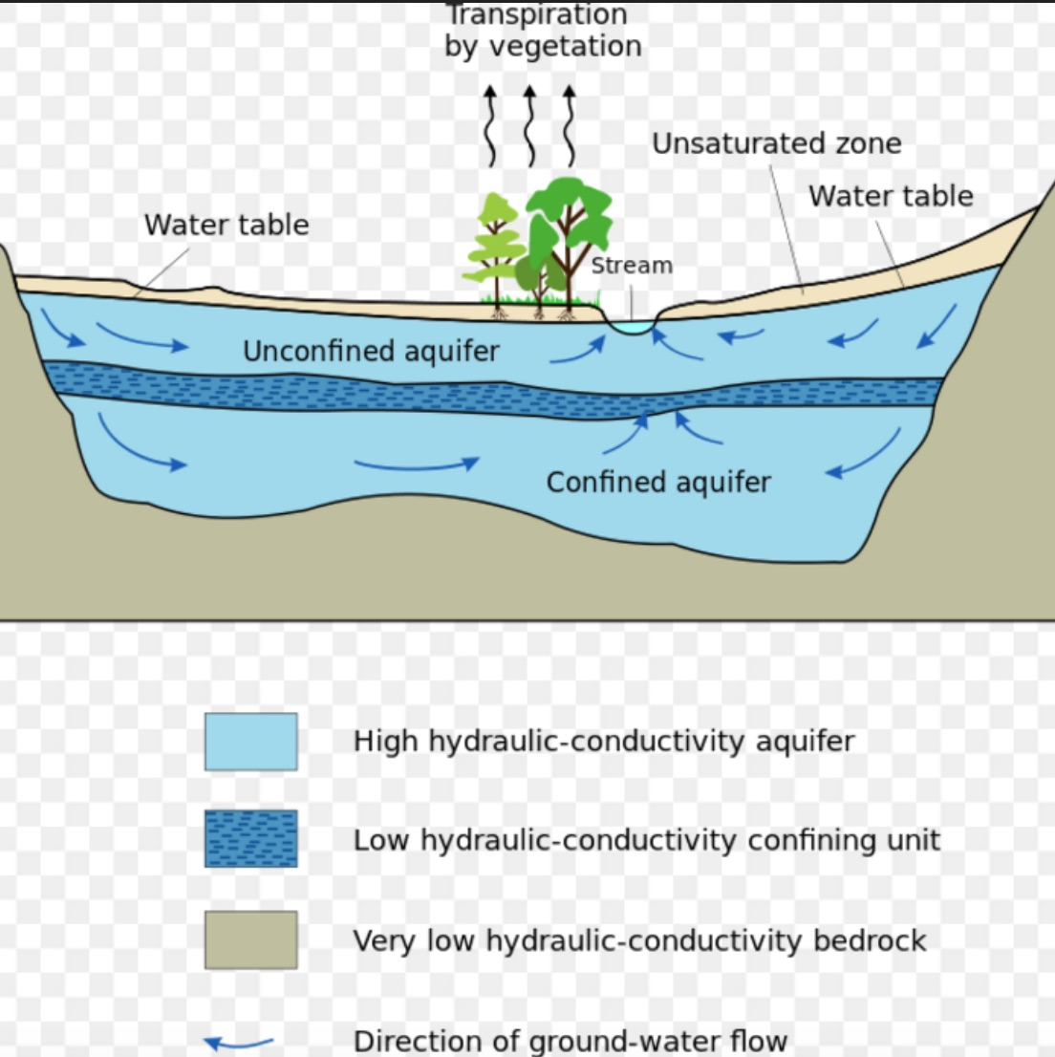

The terrain in this part of Florida, known as Bone Valley, is a unique mix of sand, phosphate pebbles, and clay. These substantial phosphate deposits are considered a major distinguishing feature of the area and have been mined for commercial fertilizer production for decades. The problem in Polk County is the area also contains large amounts of limestone, dolomite, and gypsum — all materials that are soluble in water. This makes the entire region prone to sinkholes, caves, and other similar rock formations. Combine sinkhole-friendly strata with extensive mining, and you’ve got a recipe for water pollution.

The radioactivity comes into play because the phosphate deposits we mine for fertilizer are weakly radioactive to start with, at roughly 100 ppm. The phosphate ore is treated with sulfuric acid, creating a byproduct known as phosphogypsum. Phosphogypsum is somewhat more radioactive than the raw ore, since the treatment process concentrates the radioactivity that was present initially. Phosphogypsum is stored in huge “stacks,” but since it emits radon initially, the stacks are covered in water. Over time, as the [water](http://www.extremetech.com/tag/water) evaporates, the stack forms a thick crust that seals at least some of the radon gas and prevents the phosphogypsum from blowing in the wind and creating dust storms. The sinkhole that opened in Tampa short-circuited this process by draining the water directly into the water supply.

For now, Mosaic is offering free water testing to concerned residents and has already set up a recovery well pumping 3,500 gallons of water per minute out of the affected area, to try and recapture some of the contaminated material. But this particular stack will continue to leak into the aquifer until the hole is physically plugged, which could still take months. Bone Valley currently contains roughly one billion tons of phosphogypsum in these various stacks. No current plan exists for repurposing the material, though there have been various proposals to use it for road pavement, a landfill cover, or for artificial reefs.