1.
Proposal Cover Sheet
Term: Fall _X __ Spring _____ Year 2011_
Instructor: Nora Demers
Name: Geoffrey Thomas_________________________
Present Year in Education: Junior__________________________________
E-mail Address: gpthomas@eagle.fgcu.edu__________________________
Major: Environmental Studies_____________________
Have you identified a research mentor for a senior thesis (if applicable)? _____ Yes __X__ No.
Title of Proposal:
How the various modes of propagation by Cladium jamaisence affects the genotypic structure in populations of sawgrass in the Florida Everglades
Checklist:
All required portions of the first submission are included __X__ Yes _____ No
I had an external reviewer read the proposal _____ Yes __X__ No
If Yes, who ________________________________________ When _______________
I authorize the use of this proposal as an example in future courses __X__ Yes _____ No

2.
Abstract:
Cladium jamaicense is found extensively throughout the Everglades ecosystem, and can propagate by both sexual and asexual means (Miao 1998). This study will examine the genotypic diversity of sawgrass populations through horizontal gel-electrophoresis of field samples, in the Water Conservation Areas and Florida’s Everglades National Park. The results will consider how the various modes of propagation of C. jamaicense affect the genetic structure of their populations, and assess whether asexual formation of clonal plantlets from C. jamaicense has lowered genotypic diversity of the Eastern Everglades’ sawgrass.

3.
Table of Contents
Section: Page Number:
Proposal Cover Sheet
Abstract
Table of Contents
Introduction
Research Objectives | 5.
Study Design | 5.
Data Collection | 6.
Data Analysis | 7.
Broader Implications | 7.
References Cited | 8.
Curriculum Vitae | 9.

4.
How the various modes of propagation by Cladium jamaisence affects the genotypic structure in populations of sawgrass in the Florida Everglades
Introduction:
Cladium jamaicense (sawgrass) is a perennial sedge found extensively in the Florida Everglades, and can spread through both sexual and asexual methods of reproduction. This means they can distribute seeds (sexually), or produce horizontal rhizomes or form plantlets among the reproductive organs (asexually) (Miao 1998). The ability to produce clone plantlets, on the buds of flowers, that co-exist with the flower itself has only been reported by two other species of plants (Miao 1998). C. jamaicense is highly adapted to its environment: they can live under a range of inundation levels and periods (Todd 2010), germinate in saturated conditions (Ponzio 1995), and have a relatively low and slow nutrient uptake rate (Lissner 2003). These various modes of propagation are a survival mechanism that has successfully allowed sawgrass to expand across the nutrient poor Everglades.
Stands of C. jamaicense trap sediments and other decaying organic matter around the base of the stalks and roots, and become built-up into ridges directed parallel to water flow (Ogden 2005). Sawgrass ridges are self-organized through feedback mechanisms and can control topographical elevation and hydrology (Watts 2010). Some of these feedback mechanisms are hydrology, nutrient availability, and competition of other plant species. These ridges are important for controlling the flow of water, primary production (Ogden 2005), releasing phosphorus into the hydrologic system from organic matter that becomes trapped, and providing essential habitat to many different organisms.
Loss of feedback mechanisms caused by 20th century water management practices has had a significant impact on the landscape of the Everglades and its plant communities (Bernhardt 2009). Without essential feedback mechanisms sawgrass ridges cannot be sustained. As the water is drained from a previously inundated area, there will be a loss of ridges and topographical flattening will occur (Watts 2010). As water is pumped into a previously dryer area, higher water levels force competition between sawgrass and other slough plant communities. C. jamaicense cannot successfully compete with other plant species when water and nutrient levels are higher than average due to its low nutrient absorption rate (Ponzio 1995, Chiang 1999). Other competing plants with a higher nutrient absorption rate, such as Typha domingensis (cattail), simply outgrow sawgrass.
By producing clone plants that become clustered together (Ivey and Richards 2001 b.), C. jamaicense may be reducing the possibility of sexually reproducing with other members close by because of sawgrass’ low recruitment rate of seedlings demonstrated in laboratory study (Webb 2008). If the rate of clonal production of plantlets is higher than that of sexual reproduction, genotypic diversity may be reduced in populations due to the lack of gene flow. Lower genotypic diversity in populations of sawgrass would reduce their likelihood of reestablishment after a large-scale disturbance such as a fire, hurricane, or alteration of water management practices.

5.
Research Objectives:
This proposal will attempt to determine how the various modes of propagation of C. jamaicense have affected its genotypic structure in populations of sawgrass in the Everglades. By exposing the existing genotypic diversity, with horizontal starch-gel electrophoresis, in populations of sawgrass and comparing results from a similar, previous study done (Ivey and Richards 2001 b.), changes in genotypic diversity can be observed in populations of sawgrass in the Everglades over time. The hypothesis being tested is whether the asexual formation of clonal plantlets from C. jamaicense has led to a decrease in genotypic diversity within populations of sawgrass in the Everglades.
Study Design:
18 sampling sites have been selected throughout water conservation areas WCA1, WCA2, WCA3, and Everglades National Park in the Florida Everglades (Ivey and Richards 2001 a.) (Fig. 1). WCA1, WCA2, and WCA3 are water conservation areas that have had their hydrology changed from historical patterns by water management practices. These sampling areas have been chosen because sawgrass is found in greater numbers in the Eastern Everglades. Samples will be collected from each site using scissors and Horizontal starch-gel electrophoresis will be used to examine genotypic diversity within populations. Samples with different multilocus allozyme phenotypes will be considered to represent different genotypes (Ivey and Richards 2001 b.)
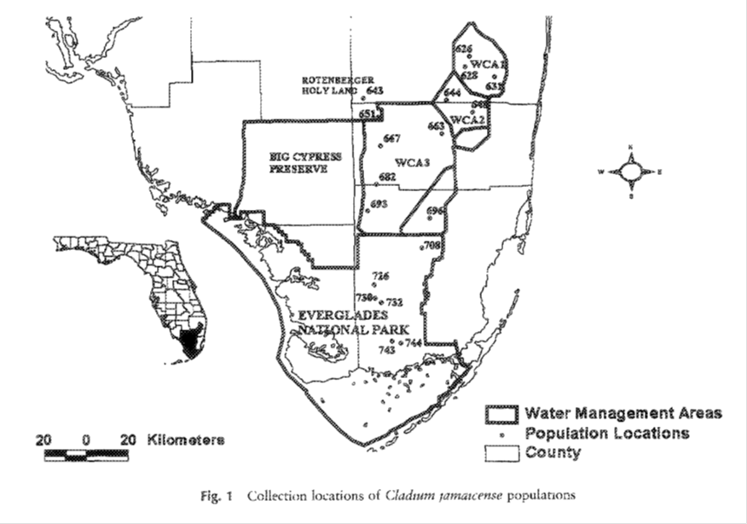

6.
Data Collection:
Two previous studies in 2001 by Christopher Ivey and Jennifer Richards, examined the genetic diversity and the genotypic diversity and clonal structure of Everglades sawgrass. These two studies are similar in design to the proposed study and have been helpful in the design and data interpretation processes. Assuming that their methods and data are accurate, statistical processes will be borrowed and results will be compared to their findings.
An 11m transect will be made at each designated site with six, 1m² sampling areas, placed on alternating sides. Eight samples will be collected in each 1m² area in a replicated grid pattern (Ivey and Richards 2001 a.) (Fig. 2). Leaf material will be collected from the ramets most closely rooted at each sampling point, within a 15cm radius. If no ramets occur within a 15cm radius of the sampling point, no samples will be taken from that position. The leaf material will be placed in bags and stored on ice, until enzyme extraction takes place. An estimate of ramet density will be made at each site, by counting the numbers of culms in the third quadrat from each transect.
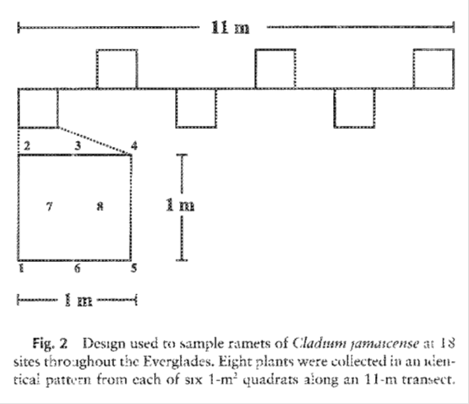
Leaves will be crushed to fine powder in a mortar using liquid nitrogen and sand, then a potassium phosphate extraction buffer will be added to the powder to stabilize the enzymes, and finally the extraction will be filtered through Miracloth and absorbed onto 8 × 3-mm wicks cut from 3M chromatography paper (Ivey and Richards, 2001a). The wicks will be stored at -80°C until electrophoresis can be performed. Horizontal starch-gel electrophoresis will be used to estimate genotypic diversity after leaf material has been treated and prepped.

7.
Data Analysis:
To estimate genotypic diversity in populations, the number of genotypes per population will be divided by the proportion of distinguishable genotypes as G/N (Ivey and Richards, 2001b). To estimate evenness of genotypic diversity, the complement of Simpson’s index for each population will be calculated as, $D = 1 – Σ[Ni(Ni - 1)/N(N - 1)].$ A second estimate of genotypic evenness, not influenced by sample size, will be calculated as, $E = (D - Dmin)/(Dmax – Dmin)$ (Ivey and Richards, 2001 b.). The unit Dmin is, $Dmin = [(k – 1)(2N – k)]/ [N(N – 1)]$, Dmax is, $Dmax = [(k – 1)N]/ [k(N – 1)]$, and k = the number of multilocus genotypes in the population. The maximum number of possible genotypes within each population and its expected frequency in a population will also be determined (Ivey and Richards 2001 b.) A two-way ANOVA test will be used to examine clustering of clones by calculating the distance between all possible pairs of ramets that have the same genotype within each population and compare them to distances between pairs of non-clone plants (Ivey and Richards, 2001 b.). The probability of clonal identity as a function of distance in populations, an indirect estimate of the relative success of asexual vs. sexual reproduction, and mean clone area will also be evaluated.
Broader Implications:
Sawgrass ridges are important in the direction of historical sheet flows and topographical elevation in the Florida Everglades. The hydrologic alteration of the Everglades done by the Army Corps of Engineers in 1948, has demonstrated how hydrologic alterations can affect plant communities. By understanding how the various modes of propagation of C. jamaicense affects the genotypic structure in populations of Everglades’ sawgrass, predicting how populations would respond to a disturbance would benefit the extensive restoration efforts of sawgrass and best water management practices by the state.

8.
Literature Cited
Bernhardt, Christopher E., and Debra A. Willard. 2009. Response of the Everglades ridge and slough landscape to climate variability and 20th-century water management. Ecological Applications 19:1723–1738.
Chiang, Connie, Craft, Christopher B., Rogers, David W., and Richardson, Curtis J. 2000. Effects of 4 Years of Nitrogen and Phosphorus Additions on Everglades Plant Communities. Aquatic Botany 68:61-78.
(a.) Ivey, Christopher T. and Richards, Jennifer H. 2001. Genetic Diversity of Everglades Sawgrass, Cladium jamaicense (Cyperaceae). International Journal of Plant Sciences 162:817-825.
(b.) Ivey, Christopher T. and Richards, Jennifer H. 2001. Genotypic Diversity and Clonal Structure of Everglades Sawgrass, Cladium jamaicense (Cyperaceae). International Journal of Plant Sciences 162:1327-1335.
Lissner, Jørgen, Mendelssohn, Irving A., Lorenzen, Bent, Brix, Hans, McKee, Karen L., and Miao, Shi Li. 2003. Interactive Effects of Redox Intensity and Phosphate Availability on Growth and Nutrient Relations of Cladium jamaicense (Cyperaceae). American Journal of Botany 90:736-748.
Miao, S. L., Kong, L., Lorenzens, B., and Johnson, R. R. 1998. Versatile Modes of Propagation in Cladium jamaicense in the Florida Everglades. Annals of Botany 82: 285-290.
Ponzio, Kimberli J., Miller, Steven J., and Lee, Mary Ann. 1995. Germination of Sawgrass, Cladium jamaicense Crantz, Under Varying Hydrologic Conditions. Aquatic Botany 51:115-120.
Todd, M. Jason., Muneepeerakul, R., Pumo, D., Azaele, S., Miralles-Wilhelm, F., et al. 2010. Hydrological drivers of wetland vegetation community distribution within Everglades National Park, Florida. Advances in Water Resources 33: 1279-1289.d
Watts, Danielle L., Cohen, Matthew J., Heffernan, James B., Osborne, Todd Z. 2010. Hydrologic Modification and the Loss of Self-organized Patterning in the Ridge–Slough Mosaic of the Everglades. Ecosystems 13: 813–827
Webb, James., Miao, Shi Li and Zhang, Xing-Hai. 2008. Factors and mechanisms influencing seed germination in a wetland plant sawgrass. Plant Growth Regulation 57: 243-250.

9.
Geoffrey P. Thomas
75 Mentor Drive, Naples, FL 34110
(239)-595-1553
Education:
2009 – Present: Florida Gulf Coast University Fort Myers, FL 33965
Major: Environmental Studies
Minors: Biology and Interdisciplinary Studies
Work Experience:
2004-2006: Lawn maintenance/ Landscape architecture: Jean McCullough LLC. Bonita Springs, FL
2006-2008: Cashier: Sweetbay Supermarket. 2482 Immokalee road Naples, FL 34110
2008-2009: Cashier/ Order taker: Jason’s Deli. 2700 Immokalee road #1 Naples, FL 34110
Special Skills:
• Experience with water sampling techniques
• Familiar with native plant species
• Small craft operation (boating license)
• Familiar with laboratory safety and practices

