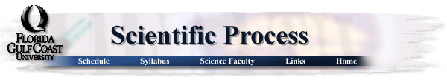
Proposal Cover Sheet
Term: Fall__X___ Spring _____ Year _2011_
Instructor __Demers__
Name: Colleen Chabot
Present Year in Education (e.g., freshman, sophomore, etc.): Senior
E-mail Address: cachabot@eagle.fgcu.edu
Major: Marine Science
Have you identified a research mentor for a senior thesis (if applicable)?
_____ Yes __X___ No.
If yes, please identify.
Name: __________________________________________
Title of Proposal:
Sewage effluent from two major resorts on Key West (Southern Most and Ocean Key Resort) increases the frequency of coral disease on the reefs in close proximity to the resorts.

Keywords (3-5)
Sewage outflow, coral disease, enteroccoci ______________________________________________________________________________
Checklist:
All required portions of the first submission are included _____ Yes _____ No
I had an external reviewer read the proposal _____ Yes _____ No
If Yes, who ________________________________________ When _______________
I authorize the use of this proposal as an example in future courses _____ Yes _____ No

Abstract
Coral reefs are in decline all over the world due to many anthropogenic stressors. One of these stressors is the outflow of sewage due to inadequate sewage treatments plants. The bacteria from the sewage effluent have many negative impacts on coral health; it has been shown that the sewage outflow increases the frequency of coral disease. Studies have been done in the upper Florida Keys, looking at the levels of enteroccoci in relation to the health of the coral reefs. The results showed a significant relationship between the two sets of data, which is what this study will be doing in two pinpointed locations surrounding the island of Key West.

Table of Contents
Abstract . . . . . . . . . . . . . . . . . . . . . . . . . . . . . . . . . . . . . . . . . . . . . . . . . . . . . . . . . .1
Project Summary
Introduction . . . . . . . . . . . . . . . . . . . . . . . . . . . . . . . . . . . . . . . . . . . . . . . . . . . 3
Materials and Methods . . . . . . . . . . . . . . . . . . . . . . . . . . . . . . . . . . . . . . . . . . 4
Research objectives. . . . . . . . . . . . . . . . . . . . . . . . . . . . . . . . . . . . . . . . . . . . . .4
Broader Implications. . . . . . . . . . . . . . . . . . . . . . . . . . . . . . . . . . . . . . . . . . . . .5
Figures . . . . . . . . . . . . . . . . . . . . . . . . . . . . . . . . . . . . . . . . . . . . . . . . . . . . . . . 6
References Cited . . . . . . . . . . . . . . . . . . . . . . . . . . . . . . . . . . . . . . . . . . . . . . . . . . . . . . 7
Curriculum Vitae . . . . . . . . . . . . . . . . . . . . . . . . . . . . . . . . . . . . . . . . . . . . . . . . . . . . . . 9

Project Summary
Introduction
All over the world coral reefs have been polluted by sewage, which has lead to a major environmental problem because little attention is paid to the chemistry of the runoff (Pastorok and Bilyard 1985). Sewage effluent can have many negative effects on coral reefs and their ecosystems (Johannes and Betzer 1975). Corals are very delicate animals that can only tolerate certain narrow ranges of variables, so anything outside of that narrow range can be detrimental to coral growth and survival (Johannes and Betzer 1975). Coral reefs that are already under other anthropogenic stressors are more susceptible to changes in nutrients and can cause symptoms similar to those expected from nitrification (Szmant 2002).
Coral disease has been found to be very prevalent all throughout the Florida Keys (Richardson 1998). Due to the nature of the porous limestone, which makes up the strata of the islands, sewage disposal practices in the Florida Keys may be inadequate for the protection of water quality (Griffin et al 1999). Studies performed in the upper and lower keys have found that surface water surrounding islands with septic tanks have had high levels of microbes and fecal indicators (Paul et al 1995).
Key West was chosen as the site for research because it is has a steadily growing population of residents and tourists, which increases the need for proper waste treatment (Wetz et al 2004). The reefs surrounding Key West are fringing reefs with highly productive ecosystems which are important to the people inhabiting the island for eco-tourism as well as a food source (Jaap 1984). Key West is one of the only 3 islands of the Florida Keys that is served by a full scale treatment plant and injection well disposal (Griffin et al 1999).
Two resorts were selected as sites for this study, to see if these could be pin-pointed as areas for increasing the quality of wastewater treatment on the island of Key West. These two resorts were chosen because they are on opposite ends of the island with reefs in close proximity to them. A control site outside of Fort Zachary Taylor, has also been selected as a control because it is not in close proximity to a resort. The results of this study may lead to suggestions of changing the sewage treatment plants on the island of Key West, as seen in other studies done in the upper keys (Wetz et al 2004).
Research Objectives
The objective of this research is to get quantitative data on the relationship from the presence of enteroccoci, due to sewage outflow, and the frequency of coral disease. The data that is acquired will then be compared to other studies that have been done in different parts of the Florida Keys, for comparison.
Materials and Methods
Sample Collection:
Three stations (Fig. 1) will be visited three times each on three different days. Each sample will be taken in the morning hours (9-10 A.M.). Water samples will be taken at depth, right next to the coral as well as surface samples. Samples at depth will be taken while SCUBA diving by two AAUS certified divers. Samples will be taken for analysis in sterile, 1-1 polypropylene bottles which will then be placed on ice and taken straight to the lab to be tested within four hours (Wetz et al 2004) . Depth, salinity, pressure and density will also be measured using a conductivity-depth-temperature device. At each site the divers will also do a survey of the reef noting coral diseases (Fig. 2, Hudson and Diaz 1988).
Laboratory Analysis:
All water samples will be analyzed, checking for microbial indicators (Wetz et al 2004). This will be done by following the USA EPA methodology, which includes taking 5-50 ml of each water sample and filtrated through a membrane which retains bacteria. After the sample is filtrated, the membrane containing the bacterial cells are incubated for 24 h. All enteroccoci colonies are counted by using magnification and a small fluorescent lamp (Wetz et al 2004, US Environmental Protection Agency 1997).
Data Analysis:
After the receiving data indicating the enteroccoci levels, as well as the coral disease data, an ANOVA test will be used to test for significance between presence of coral disease and levels of enteroccoci. Each site and day will have its own ANOVA test, as well as an overall test.
Expected Results
It is expected that the frequency of coral diseases will be higher and that there will be high levels of enteroccoci at the coral reefs in close proximity to the resorts.
Broader Implications
This study would provide data that could be used to help stop the destruction of coral reefs not only in Key West, but all over the world. If there is a significant relationship in the data that means that there is still sewage outflow from the island, due to insufficient sewage treatment plants. This could lead to new sewage treatment plants that are more suitable for the environment of the Florida Keys, because of its limestone porous ground.

Fig. 1 The study sites, starting from the southern site which is Southern Most Resort (A) to the northern site which is Ocean Key Resort (B) and the control site which is outside of Fort Zachary Taylor State Park (C).
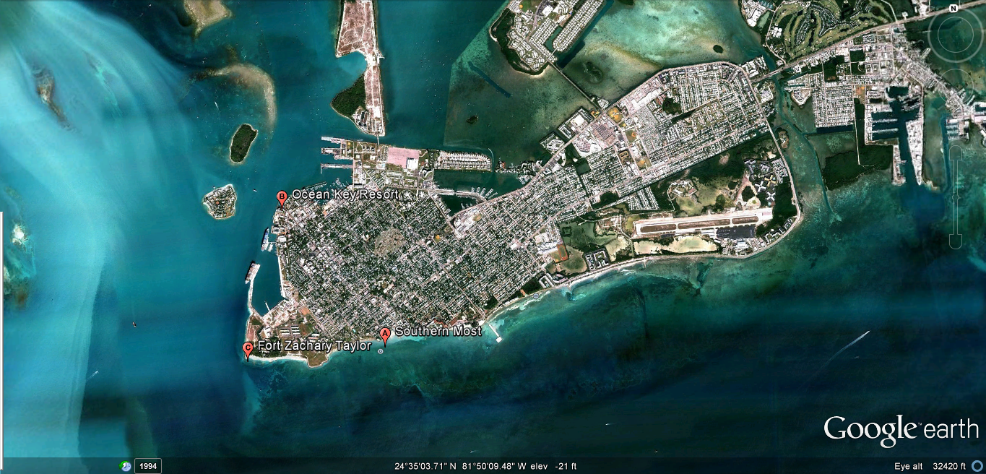
Fig. 2 Coral survey procedure taken from Hudson and Diaz 1988.
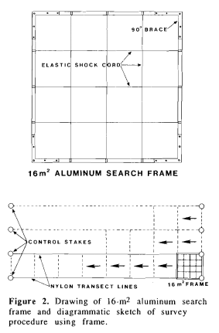

Refrences Cited
Griffin, D. W., C. J. Gibson, I. I. I., E. K. Lipp, K. Riley, J. H. Paul III, and J. B. Rose. 1999. Detection of viral pathogens by reverse transcriptase PCR and of microbial indicators by standard methods in the canals of the Florida Keys. Appl. Environ. Microbiol. 65:4118-4125.
Hudson, J. H. and Diaz, R. (1988) Damage survey and restoration of M/V Wellwood grounding site, Molasses Reef, Key Largo National Marine Sanctuary. Proceedings of the Sixth International Coral Reef Symposium 2, 231±236.
Jaap, W.C., 1984. The ecology of the south Florida coral reefs: A community profile: U.S. Fish and Wildlife Service, FWS/OBS-82/08, 138 p.
Johannes, R. E., Betzer, S. B. 1975. Introduction: marine communities respond differently to pollution in the tropics than at higher latitudes. Tropical marine pollution 1-12.
Pastorok, R.A., Bilyard, G.R. 1985. Effects of sewage pollution on coral reef communities. Marine Ecology Progress Series 21: 175-189.
Paul J.P., Rose J.B., Brown J, Shinn E.A., Miller S and Farrah S.R. 1995. Viral tracer studies indicate contamination of marine waters by sewage disposal practices in Key Largo, Florida. Applied and Environmental Microbiology, 61: 2230–2234.
Richardson, L.L. 1998. Coral diseases: What is really known? Trends in Ecology and Evolution 13: 438-443.
Szmant, A.M. 2002. Nutrient enrichment on coral reefs: Is it a major cause of coral reef decline? Estuaries 25:743-766.
US Environmental Protection Agency, 1997 US Environmental Protection Agency, 1997. Method 1600: Membrane Filter Test Method for Enterococci in Water. EPA-821-R-97-004.
Wetz, J.J., Lipp E.K., Griffin D.W., Lukasik J., Wait D., Sobsey M.D., Scott T.M., Rose J.B. 2004. Presence, infectivity, and stability of enteric viruses in seawater: Relationship to marine water quality in the Florida Keys. Marine Pollution Bulletin 48:698-704.

Colleen Chabot
9204 Pineapple Road Fort Myers, FL 33967
513-884-2808
cachabot@eagle.fgcu.edu

GOALS
After receiving my bachelors of science degree in Marine Science, I plan on attending graduate school for another degree in Marine Science/Biology. After that I plan on getting a marine research position, or pursuing a career in marine conservation.

EDUCATION

BS: Florida Gulf Coast University, August 2008-present, Marine Science

Semester Abroad: Spellman School: CIEE Bonaire, Spring 2010, Tropical Marine Ecology and Conservation

Supplementary:
PADI SCUBA certified: Open water, advanced open water and rescue; American Academy of Underwater Scientific diving certified, experience tagging sharks with Florida Gulf Coast University/University of Miami.
Courses:
Tropical Marine Ecology and Conservation, Coral Reef Ecology, Marine Ecology and Field Research Methods, Water Management, Field and Lab Marine Science, Costal Zone Management, Oceanography, Physical Oceanography.

PROFESSIONAL SOCIETIES
Florida Gulf Coast University’s Honors program Fall 2008-present.

SERVICE
Volunteer:
Volunteer at Newport Aquarium (KY) from 2004-2008, Seafood Savvy volunteer, Solutions to avoid Red Tide volunteer.
Academic service:
President of Save Our Seas Club at Florida Gulf Coast University 2010-2011, President of American Humane Association honors service team 2009-2011.
Community outreach:
As a volunteer for Florida Gulf Coast University’s marine lab, I attended many community events speaking on behalf of them about their research done on sharks.
PRESENTATIONS & PUBLICATIONS

Academic Publications:
CIEE Bonaire’s Journal: Physis volume VII

