Rheumatoid Arthritis “An Autoimmune Mystery”

Cynthia R. Anderson

Florida Gulf Coast University

Immunology – PCB 4233C

December 1, 2005

In many conversations with my brother in law is where I first learned about Rheumatoid Arthritis. The swollen joints were noticeable and he was always stiff and sore. He told me that the condition came from having rheumatic fever as a child. After studying immunology, I found out that the exact cause was unknown, but researchers discovered that it was an autoimmune disease. In this paper, I will discuss the present theories of what causes this condition, how it affects various age groups, common symptoms, diagnostic testing, and treatment used to help patients live with this disease.
Rheumatoid Arthritis is a chronic disease whose characteristics are inflammation of the lining of the joints. It can occur at any age but begins most often between the ages of 25 and 55. Women are at risk three times more than men, due to female hormonal activity. There is not an exact cause but researchers have discovered that something goes wrong in the immune system and the body’s defenses attack its own joint tissue. It progresses in three stages, swelling of the synovial lining which causes pain, stiffness and swelling around the joint, rapid growth of cells which makes the synovium thicken, and the inflamed cells release enzymes that can digest bone and cartilage causing the joint to become disfigured, painful and difficult to move.
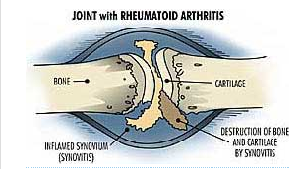
Patients with RA have pain and discomfort in joints on both sides of the body, called symmetrical, a major characteristic in this disorder. Joints of the feet, hands, wrists and knees are most affected, but can move to other parts of the body as the disease progresses (“Arthritis Foundation, 2004”).
Dr. Alfred Baring Garrod, officially named the condition of Rheumatoid Arthritis in 1859 in England. It was different than the diagnosis of rheumatism and gout, which he discovered earlier in 1848. He noted that it was a chronic disorder, leading to permanent abnormality by the bone damage (“Oxford Journals, 2001”). In 1912, Dr. Frank Billings introduced the concept of the focal infection to American physicians. This concept was that infections and contagious disease came from infected teeth and tonsils. With this concept, Dr. Billings believed that arthritis came from a bacterial infection.
Over the years, many scientists searched for a link between different infections and the development of Rheumatoid Arthritis. In the late 1920’s, tuberculosis was suspected as well as the streptococcal infection of Rheumatic Fever. Rheumatic Fever is an inflammatory disease that develops after a strep infection, such as strep throat or scarlet fever, and affects the heart, joints, skin and brain. Other organisms suspected were, Mycoplasma, E. Coli, and Proteus. In the 1950’s, two investigators tried to transmit Rheumatoid Arthritis to volunteers injecting their joints with fluid, from the fluid of the joints from people with the disease. The volunteers were not affected, which proved that it was not a contagious disease. There is present consideration that viruses such as Epstein Barr, Rubella and Parvovirus might be causing this disorder. Many theories were tested, but no concrete reason was supported (“Living with Rheumatoid Arthritis, 2003”).
The most common symptoms in adults with Rheumatoid Arthritis are pain and swelling in the joints, stiffness in the morning and after sitting long periods of time, fatigue, low grade fever, loss of motion, loss of strength in muscles (“Mayo Clinic, 2005”). “Advanced changes to look out for include damage to cartilage, tendons, ligaments and bone, which causes deformity and instability in the joints. The damage can lead to limited range of motion making daily tasks more difficult” (Arthritis Foundation, 2004”).
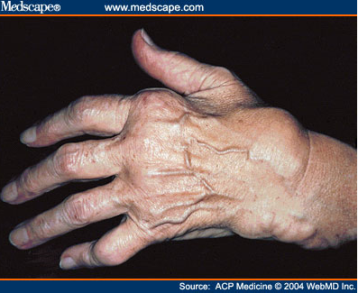
Children can also be affected. Juvenile Rheumatoid Arthritis causes the same joint inflammation and stiffness in children 16 years of age or less. Doctors classify Juvenile Rheumatoid Arthritis into three types by the number of joints involved. Pauciarticular is the most common, where four or fewer joints are affected, and affects the large joints such as the knees. Polyarticular, five joints or more are affected, which includes small joints, like the hands and feet. Systemic, besides joints swelling, internal organs are affected, heart, spleen and lymph nodes. These patients have fever and a light skin rash. “Although many children don’t complain, any joint can be affected and the inflammation will limit mobility of the affected joints” (NIAMS, 2001”).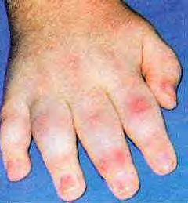
The physician uses clinical history, physical exam and laboratory tests to diagnose Rheumatoid Arthritis in conjunction with symptoms observed in patients of all ages. A complete blood count (CBC) is performed to detect the values of red cell count and hematocrit (red cell volume) which is lower in people with RA and is the cause of their fatigue due to anemia. The Erythrocyte Sedimentation Rate (ESR) is used to assess inflammation. In the setting of inflammation the body produces many proteins which can make red blood cells line up under each other. In this test the blood is placed in a tube, and the greater the level of inflammation, faster the red cells fall in the tube which elevates the ESR results. With treatment the value lowers, so doctors repeat this test to monitor inflammation in RA patients. Another test for the presence of inflammation is the C-reactive protein. CRP is a special type of protein produced by the liver that is present during episodes of acute inflammation. The most important role is its interaction with the complement system, which is one of the body’s immunologic defense mechanisms. When levels are elevated, disease activity is detected. If it remains high over a long period of time, it indicates severe joint damage later in the disease. It should be repeated regularly to monitor inflammation and check the patient’s response to medication.
There are test for specific antibodies. Rheumatoid Factor is an antibody direct against the Fc fragment of IgG. It is usually a IgM antibody but may be IgG or IgA. It is present in 70% to 80% of patients with Rheumatoid Arthritis. It is performed by latex agglutination, a slide test with positive or negative results. (“Guide to Good Living with Rheumatoid Arthritis, 2004”). Anti CCP, which stands for anti-cyclic citrullinated peptide antibody is a new blood test that helps doctors confirm a diagnosis of rheumatoid arthritis. If present in a patient at a moderate to high level along with the positive RF latex test, 90% of patients are diagnosed with RA. Imaging studies are also used such as X-Ray, MRI, CAT scan and Bone scan. Most physicians use X-Rays because they can get results fast and at less cost to patients.
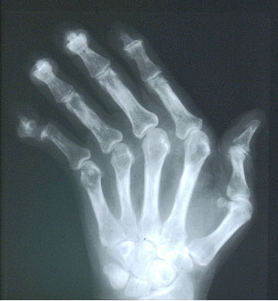
What happens to the immune system in Rheumatoid Arthritis? For some unknown reason the joints are infiltrated by leukocytes into the joint synovium consisting of T cells, B cells, neutrophils, macrophages, and plasma cells that make Rheumatoid Factor. Prostaglandins and leukotrienes produced by inflammatory cells are mediators of the inflammation. The neutrophils release lysosomal enzymes into the synovial space that cause damage to the tissues and proliferation of the synovium. Proteinases and collagenases produced by inflammatory cells within the joint can also damage cartilage, ligaments and tendons (“Parham, p. 352, 2005”).
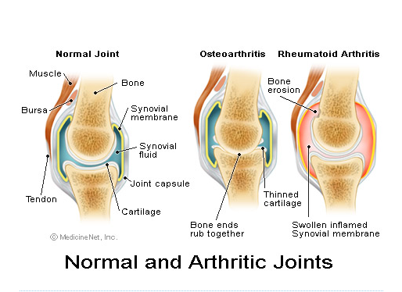
Now that the mechanics of this disorder are known, scientists are working hard to find the cause. Genetic markers HLA-DR4 and DR1 were identified in some people with RA. There have been new insights that stress may play a role, such as a physical trauma, emotional upheaval, or anything that causes the body to produce a response to stress. Infections such as Epstein Barr Virus, Parvovirus, Lyme disease and Malaria, which produce symptoms similar to RA, have not been left out (Rheumatoid Arthritis – Everything You Need to Know, 2001”).
Today’s patient can live with Rheumatoid Arthritis. There are alternative and conventional methods of treatment available. Alternative methods include herbal medicines, acupuncture, massage, diet, exercise, and stress reduction techniques such as prayer, mediation, hypnosis, yoga and tai chi.
Conventional methods are medications over the counter and prescription advised by the physician to help relieve pain and discomfort. Nonsteroidal Anti-Inflammatory Drugs (NSAIDs)
are used to reduce inflammation and relieve pain. They are aspirin, ibuprofen, and the newest COX-2 inhibitor, Celebrex. This medicine helps block the COX-2 enzyme and limit the production of inflammatory prostaglandins that cause pain and swelling. Corticosteroids are injected into the joint for prevention of joint damage and inflammation but long term use can cause severe side effects. Disease Modifying Antirheumatic Drugs (DMARDs) are used to destroy joint destruction caused by RA over a period of time. Some examples of these drugs are methotrexate, injectable gold, penicillamine, hydroxychloroquine, and oral gold. Biologic Response Modifiers are drugs that inhibit cytokines (TNF, IL1) that contribute to inflammation. Enbrel, Remicade, and Humira are a few of these newer drugs that reduce pain, morning stiffness and swollen joints, within one to two weeks after treatment. They are very expensive, and given by injection only (“Mayo Clinic, 2005”).
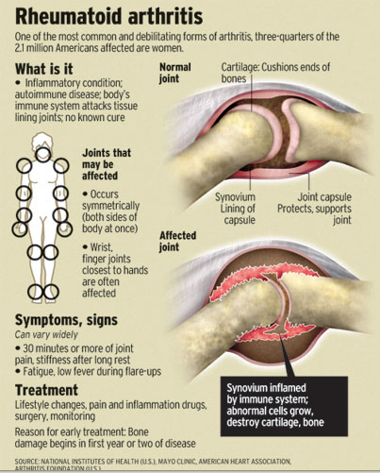
We have come a long way in our knowledge of Rheumatoid Arthritis, and the future looks promising with the new treatment available. There are pieces missing to this puzzle but with genetic research and new technology, it won’t be long before researchers find a cause and effective cure of this disease. In the meantime, patients under the care of a physician will be able to lead normal productive lives.

Works Cited

Arthritis Foundation. “Disease Center.” Arthritis Foundation. 2004. 24 Aug.2005.
<http://www.arthritis.org/conditions/DiseaseCenter/RA/ra_overview.asp>.

Arthritis Foundation. Guide to Good Living with Rheumatoid Arthritis. Atlanta:
Arthritis Foundation, 2004.

Lahita, Robert G. M.D. Rheumatoid Arthritis – Everything You Need to Know. New York:
Avery, 2001.

Mayo Clinic. “Rheumatoid Arthritis.’ Mayo Clinic.com. Mayo Foundation for Medical
Education and Research. 8 April. 2005. 10 Oct. 2005
http://www.mayoclinic.com/invoke.cfm?id=DS00020>.

National Institute of Arthritis and Musculoskeletal and Skin Diseases. “Questions and Answers
About Juvenile Rheumatoid Arthritis.” National Institute of Health. 2001 July. 10 Oct. 2005.
<http://www.niams.nih.gov/hi/topics/juvenile_arthritis/juvarthr.htm>.

Oxford Journals. “Alfred Baring Garrod.” Heberden Historical Series. British Society for
Rheumatology. 2001. 28 Oct. 2005.
<http://rheumatology.oxford journals.org/cgi/content/full/40/10/1189?eaf>.

Parham, Peter. The Immune System. New York: Garland Science Publishing, 20055.

Shlotzhauer, Tammi L. M.D. and James McGuire M.D. Living with Rheumatoid Arthritis.
Baltimore: John Hopkins University Press, 2003.



