Pharmaceutical Companies Should do a Better Job Providing AIDS Treatment

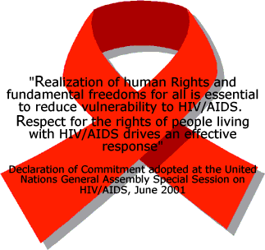
The red symbol is a symbol of solidarity for HIV-positive
People and those living with AIDS. Source Wikimedia 2006.

AIDS Clock

Throughout history human welfare and medical advancements have made it possible for several people to live longer than many individuals could have ever imagined. More recently, a number of American adolescents believe that they have been taught everything there is to know about the human body and the potential consequences of unprotected sex. However, have these same children been educated on the steps to take when one of the consequences they thought they knew all too well becomes a reality? Taking this a step further…What happens when an entire country is unaware of the potential consequences of reckless sexual practices and then have no access to treatment after it is too late? AIDS knowledge and access to treatment is unfortunately something that a number of educated Americans take for granted and something that countless Sub-Saharan Africans fear they will never be able to afford. An estimated 39.5 million people around the world are living with AIDS (Avert, 2007). In developing and transitional countries, 6.8 million people are in immediate need of life-saving AIDS drugs; of these, only 1.65 million are receiving the drugs (UNAIDS, 2006). Our concern and issue is what is happening with the 5.15 million who are not getting the medications they need to save their lives and who could get them if it was not for patents owned by pharmaceutical companies. We propose that AIDS drugs should be more affordable and readily available to underdeveloped countries so that wealth does not determine the quality and availability of treatments provided by pharmaceutical companies and their generic competitors. We intend to talk about the immunological effects of the virus, explain how anti-HIV drugs work, look at the political, economic, ethical, and cultural aspects behind our issue, as well as foundations and organizations already working towards a solution. We also plan to look at opposing arguments and try to propose a solution.

AIDS Development

Acquired immune deficiency syndrome or acquired immunodeficiency syndrome (AIDS) is a collection of symptoms and infections resulting from the specific damage to the immune system caused by the human immunodeficiency virus (HIV). The late stage of the condition leaves individuals prone to opportunistic infections and tumors. Although treatments for AIDS and HIV exist to slow the virus's progression, there is no known cure. HIV is transmitted through direct contact of a mucous membrane or the bloodstream with a bodily fluid containing HIV, such as blood, semen, vaginal fluid, preseminal fluid, and breast milk. This transmission can come in the form of anal, vaginal or oral sex, blood transfusion, contaminated hypodermic needles, exchange between mother and baby during pregnancy, childbirth, breastfeeding, or other exposure to one of the above bodily fluids. If HIV is left untreated AIDS develops.

The HIV Virus

What is HIV?
Human immunodeficiency virus — infects the cells of living organisms and replicates themselves within those cells. It attacks the special immune system cell called CD4 lymphocyte. It uses trickery such as rapid mutations to take over the bodies defenses. HIV is an uncommon type of virus called a retrovirus, and drugs developed to disrupt the action of HIV are known as antiretrovirals or ARVs. These come in a variety of formulations designed to act on different stages of the life-cycle of HIV.

The AIDS virus mutates rapidly, which makes it extremely skilful at developing resistance to drugs. To minimize this risk, people with AIDS are generally treated with a large number of ARVs that attack the virus on several fronts at once.

ARVs have proved very effective at treating people with AIDS. But they are not a cure. If treatment is discontinued the virus becomes active again, so a person on ARVs must take them for life.

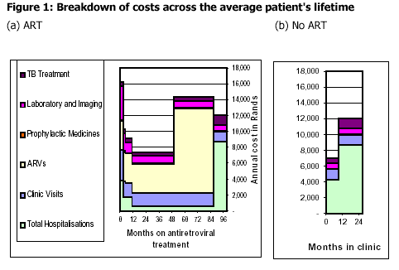
http://www.hms.harvard.edu/aids/images/SAtown.pdf
The information in the graph above is collected from HIV positive adults dependent on a public sector for care in Khayelitsha, South Africa.

Although the price of ARVs has plummeted, their cost remains an obstacle to access in the developing world. Moreover, the health infrastructure required to deliver antiretroviral therapy is lacking in many places, and only a tiny minority of the estimated six million people in need of ARVs in resource-poor countries are receiving treatment (UNAIDS, 2007).

How is HIV transmitted?
It can be transmitted in three ways:
1. Sexual transmission.
2. Transmission through blood.
- Mother-to-child.

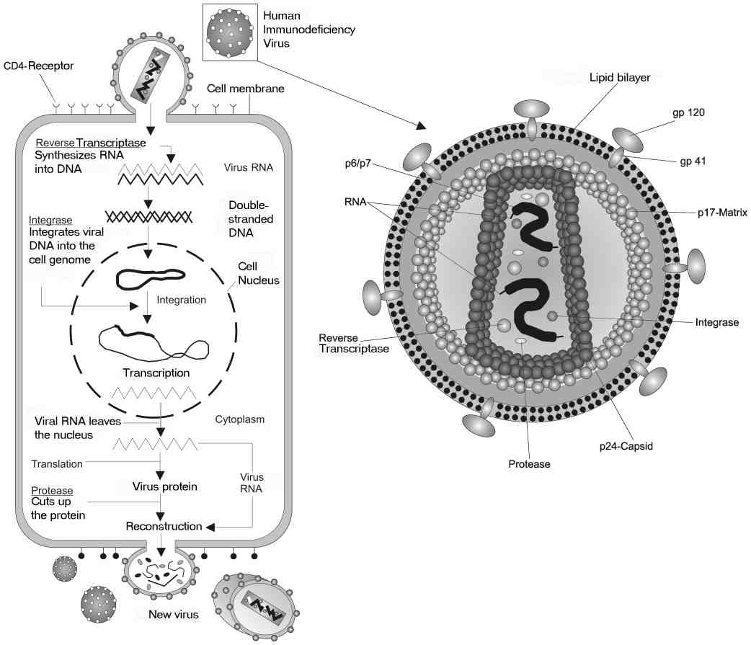
A close look at HIV. Source Wikimedia 2006.

Early Stages of HIV

CD4 cells are the immune system’s key fighter cells and also happen to be the target of the HIV virus. The destruction of these cells leaves the body prone to opportunistic infections of both the Central Nervous System (CNS) and the Peripheral Nervous System (PNS). A normal healthy individual usually has a CD4 count of approximately 800-1000 of these cells. However, a CD4 cell count below 200 is when the disease transitions between HIV and AIDS. The goal of treatment is to keep the level of CD4 cells as high as possible, to better counteract with the virus. Most scientists think that HIV causes AIDS directly inducing the death of CD4+ T cells or interfering with their normal function, and by triggering other events that weaken a person’s immune function. For example, the network of signaling molecules that normally regulates a person’s immune response is disrupted during the HIV disease, impairing a person’s ability to fight off other infections. The HIV-mediated destruction of the lymph nodes and related immunologic organs also plays a major role in causing the immunosuppression seen in people with AIDS. Immunosuppression by HIV is confirmed by the fact that medicines, which interfere with the HIV lifecycle, preserve CD4 cells as well as T cells which improve immune function and delay clinical illness (NIAID Fact Sheet).

National Institution of Allergy and Infectious Diseases

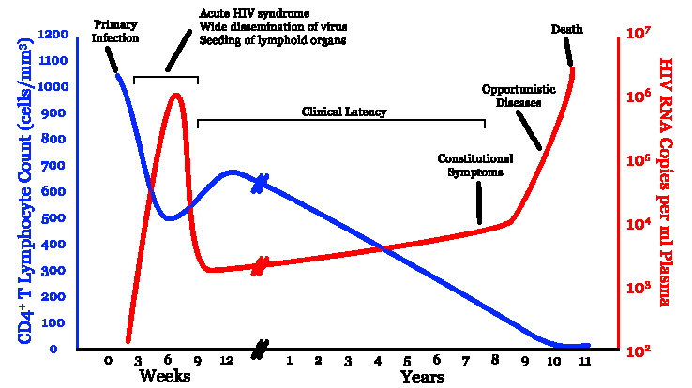

Graph showing HIV copies and CD4 counts over course of HIV infection. Image Source: Wikimedia 2006.

Introduction to HIV/AIDS Video

Dr. Becky Kuhn M.D. is the Co-founder of Global Lifeworks. It is a non-profit organization created to provide medical care in those areas most affected. This video is meant to educate and do away with myths that surround HIV/AIDS.

Science: Antiretroviral Treatments

A recent study done by UNAIDS shows that the annual cost per person for antiretroviral drug therapy in 2001 was about $11,000 a year.

What options there are:

a. Fusion or Entry Inhibitors (Fuzeon)- bind to the proteins on the outside of the HIV virus and stop it from entering the target cell.
b. Nucleoside Reverse Transcriptase Inhibitors(Epivir Ziagen, Retrovir, Abacavir, AZT, ddI, 3TC) - stop HIV copying its genes into the cell. Nucleosides are the building block for genes. The drugs
supply faulty versions of these building blocks.
c. Non-nucleoside Transcriptase Inhibitors(Sustiva, Viramune Nevirapine and Efavirenz)- also block the gene-copying process. They disable the enzyme that controls it.

d. Protease Inhibitors(Amprenavir, Lopinavir, Lexiva, Reyataz, Crixivan
Ritonavir, Nelfinavir) - disable protease, an enzyme which plays a key role in the formation of the new virus

Packaging/Pill options:

Highly Active Antiretroviral Treatment (HAART):
- 3 or more drugs taken at once (Helps with patient compliance because drugs are combined)
  - Co-blister packs – when two or more tablets are packed together
  - Fixed Dose Combinations(FDC)- Reduce # of tablets to be taken cannot accidentally leave a pill out increases adherence and limits resistance

Challenges in setting up an AIDS treatment program
/
Broken Promises Video
MSF Website

The introduction of antiretroviral drugs (ARVs) in 1996 transformed the treatment of HIV and AIDS, improving the quality and greatly prolonging the lives of many infected people in places where the drugs are available.

But in low- and middle-income countries—and especially in sub-Saharan Africa where the epidemic is most severe—only a small proportion of HIV-positive individuals have access to the drugs. Cost has been a major obstacle, although the price of ARVs has fallen dramatically in recent years due to the push by activist and the world community. Also, limitations created by the World Trade Organization creates rules and limitations of trade between nations to help producers of goods and services, exports, and imports need to conduct business.

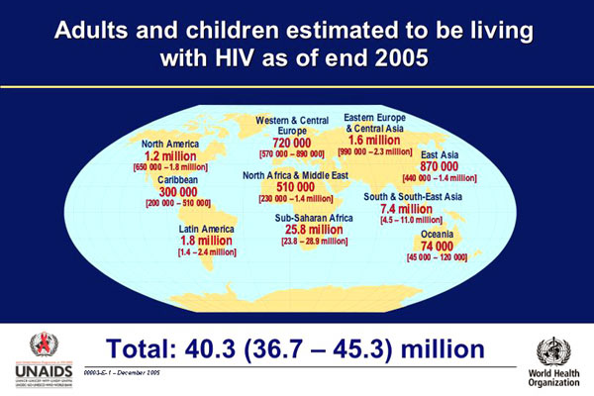
Other obstacles to access include inadequate health infrastructure and lack of people with the relevant skills and training to provide the treatment.

But access to drugs depends not only on problems with provision being sorted out. It depends also on people who need them being aware of their HIV status, knowledgeable about treatment, and empowered to seek it.

Thus public information and education are important in getting the message out so that people can be tested and possibly treated.

(UNAIDS, 2007)

Regional estimates (low- and middle-income countries only)
Region | UNAIDS/WHO estimates
Region | People receiving treatment in June 2006 | People needing treatment in 2005 | Treatment coverage in June 2006
Sub-Saharan Africa | 1,040,000 | 4,600,000 | 23%
Latin America and the Caribbean | 345,000 | 460,000 | 75%
East, South and South-East Asia | 235,000 | 1,440,000 | 16%
Europe and Central Asia | 24,000 | 190,000 | 13%
North Africa and the Middle East | 4,000 | 75,000 | 5%
All developing and transitional countries | 1,650,000 | 6,800,000 | 24%

Resource www.avert.org

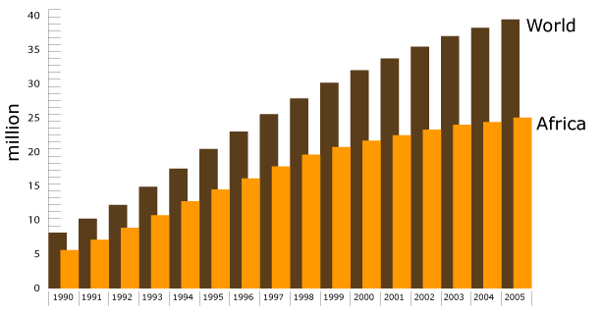
Source Avert 2007.
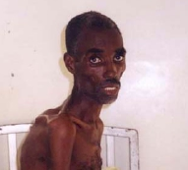

Before Antiretroviral therapy After Antiretroviral therapy
December 2000 December 2001
Source Partners in Health. Source Partners in Health.

Why In Africa?

The high AIDS epidemic in South Africa can be contributed to factors such as:
Education:
-Many individuals living in this region are not exposed to elements of birth control methods such as condom use.
- There is a myth that having sexual relations with a virgin will cure AIDS.

Culture:
-Circumcision in South Africa tends to be an underdeveloped trend, that if implemented could reduce male AIDS cases by 50-60%. This fact is due to the sensitive lining of the uncircumcised penis and the potential for cuts and bacteria to grow in this region.
-There are not as many credible treatment centers that individuals can go to
-Needle Disposing Practices are not implemented
-Many women are raped or forced into having unprotected sex
-It is not usually culturally acceptable to deny sex without a condom

Economic Status:
-Costs of treatment are high and incomes are usually fairly low, which makes it difficult to obtain treatment.
Testing:
Once infected many individuals do not have the resources to be tested, or fear others knowing of their condition.
Mother to Child:
-Many children are being born or contracting the disease at very young ages and all of the reasons above are preventing these individuals from treatment and contraction.

Definitions: Patented Drugs vs. Generic Drugs
Patents protect improvements to products, compositions, machines and processes, and cover business methods and software. Without a patent, others do not have to pay you to make, sell or use your invention. With a patent, you own your idea. You can sell or license your rights. Or you can use a patent in business to be the exclusive source (Wikepedia 2007).
“Generic drugs marketed without brand names are usually less expensive than brand-name drugs, even though they are chemically identical to brand-name drugs and meet the same standards of the FDA (US Food and Drug Administration) for safety, purity and effectiveness. Generic drugs can be legally produced in the US if a patent has expired, or for drugs which have never been patented. The expiration of a patent removes the monopoly of the patent holder on drug sales licensing” (Medterms 2007).

Epidemiology

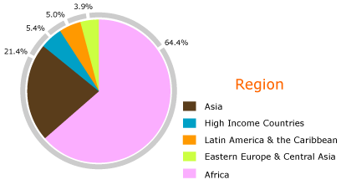
World Health Organization (WHO)

Intellectual Property
and Argument for Patents
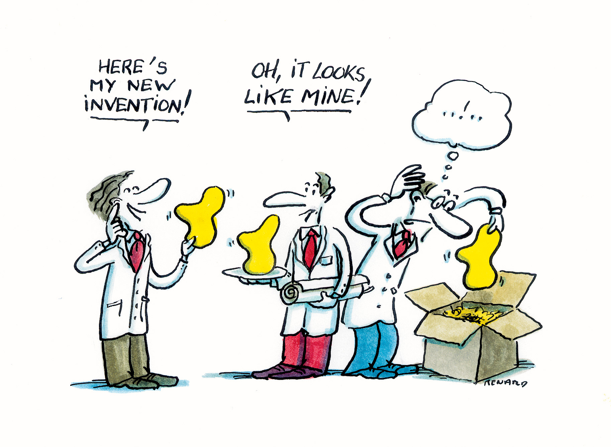
Source ESA 2007.

Intellectual property refers to creations of the mind—inventions, literary and artistic works, symbols, names, images, and designs used in commerce. Intellectual property is divided into two categories: industrial property (which includes inventions and is covered by patents) and copyright (which covers literary and artistic works) (Wikipedia, 2007)

HIV-related intellectual property falls into the first category and includes a number of important AIDS medicines and diagnostics. The patents on these products grant the pharmaceutical companies that developed them exclusive rights to make and market them for a certain period of time, typically 20 years.

The purpose of the patent is to act as an incentive for companies to make considerable investment in research and development of new drugs, knowing that, with a monopoly in the market place, they stand a good chance of recouping their investment and making a profit.

Without patent protection, the world would have been deprived of the innovative medicines which have saved countless lives.
The limited period of market exclusivity provided by patent protection allows companies to sustain the vast R&D investment necessary to invent new medicines and therapies.
The historical record demonstrates that countries with stronger patent systems experience more rapid economic growth. (IFMA, 2007)

Although we agree that these are valid arguments and we recognize the importance patents have we do not agree with the limitations they place on AIDS alone. AIDS is a worldwide issue that claims the lives of millions of people each year. In 2006 alone AIDS deaths were 2.9 million that includes children, mothers, and fathers. In Sub-Saharan Africa alone the death toll of just 2006 was 2.1 million. The ethical and most important issue behind all of this is that for the most part thanks to the technology available today many if not most of these deaths that leave thousands of children orphaned and destroys entire families and communities can be prevented with medicines.

Politics

Photo taken from http://www.gersterconsulting.ch/gallerys/gcons_webgallerieCC/images/30.jpg

TRIPS
What is TRIPS?
The Agreement on Trade Related Aspects of Intellectual Property Rights (TRIPS) is a treaty administered by the World Trade Organization (WTO) which sets down minimum standards for many forms of intellectual property (IP) regulation. It was negotiated at the end of the Uruguay Round of the General Agreement on Tariffs and Trade (GATT) treaty in 1994.

Specifically, TRIPS contains requirements that nations' laws must meet for: copyright rights, including the rights of performers, producers of sound recordings and broadcasting organizations; geographical indications, including appellations of origin; industrial designs; integrated circuit layout-designs; patents; monopolies for the developers of new plant varieties; trademarks; trade dress; and undisclosed or confidential information. TRIPS also specifies enforcement procedures, remedies, and dispute resolution procedures.

The TRIPS agreement introduced intellectual property law into the international trading system for the first time, and remains the most comprehensive international agreement on intellectual property to date. In 2001, developing countries concerned that developed countries were insisting on an overly-narrow reading of TRIPS, initiated a round of talks that resulted in the Doha Declaration: a WTO statement that clarifies the scope of TRIPS; stating for example that TRIPS can and should be interpreted in light of the goal "to promote access to medicines for all."

TRIPS has been criticized by the alter-globalization movement, regarding for example its consequences with regards to the AIDS pandemic in Africa (Wikipedia, 2007)

Doha Declaration
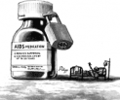
Cartoon of AIDS medications being withheld from those in need of them.
Taken from http://peopleandplanet.org/treataidsnow/takeaction/keydates

What is it?
The November 2001 Doha Declaration on the TRIPS (Trade Related Aspects of Intellectual Property Rights) Agreement and Public Health was adopted by the WTO Ministerial Conference of 2001 in Doha on November 14, 2001. It allows developing countries to manufacture generic drugs and override patents held by major pharmaceutical in times of national health crises.

In Paragraphs 4 to 6 of the Doha Declaration, governments agreed that:

4. The TRIPS Agreement does not and should not prevent Members from taking measures to protect public health. Accordingly, while reiterating our commitment to the TRIPS Agreement, we affirm that the Agreement can and should be interpreted and implemented in a manner supportive of WTO Members' right to protect public health and, in particular, to promote access to medicines for all.
In this connection, we reaffirm the right of WTO Members to use, to the full, the provisions in the TRIPS Agreement, which provide flexibility for this purpose.
5. Accordingly and in the light of paragraph 4 above, while maintaining our commitments in the TRIPS Agreement, we recognize that these flexibilities include:
(a) In applying the customary rules of interpretation of public international law, each provision of the TRIPS Agreement shall be read in the light of the object and purpose of the Agreement as expressed, in particular, in its objectives and principles.
(b) Each Member has the right to grant compulsory licenses and the freedom to determine the grounds upon which such licenses are granted.
(c) Each Member has the right to determine what constitutes a national emergency or other circumstances of extreme urgency, it being understood that public health crises, including those relating to HIV/AIDS, tuberculosis, malaria and other epidemics, can represent a national emergency or other circumstances of extreme urgency.
(d) The effect of the provisions in the TRIPS Agreement that are relevant to the exhaustion of intellectual property rights is to leave each Member free to establish its own regime for such exhaustion without challenge, subject to the MFN and national treatment provisions of Articles 3 and 4.
6. We recognize that WTO Members with insufficient or no manufacturing capacities in the pharmaceutical sector could face difficulties in making effective use of compulsory licensing under the TRIPS Agreement. We instruct the Council for TRIPS to find an expeditious solution to this problem and to report to the General Council before the end of 2002."
These provisions in the Declaration ensure that governments may issue compulsory licenses on patents for medicines, or take other steps to protect public health.
Paragraph 6 problem: A clause in which the World Trade Organization (WTO) stated that poor countries that do not have the manufacturing capacity to produce their own drugs would not be able to obtain generics through compulsory licensing. The reason for this is in a clause in the TRIPS provisions that states generics that are produced under compulsory licensing are for use in the domestic market. Therefore, they should not be exported. This means that developing countries that rely upon the exports from other developing countries will not be able to get their medications anymore.

The access to essential drugs must be safeguarded in the implementation of the trade agreements. In order to develop new drugs and vaccines, we need industries with appropriate incentives for innovation, including patent rights. However, their final aim should be to secure human health and not merely economic profit (Wikipedia, 2007)

IN ENGLISH

Basically intellectual property rights are the exclusive rights of ownership on ideas or information that can be processed into tangible objects. The owner of a patent can prevent the manufacture, use or sale of the protected product in the countries where the patent has been registered. The period of ownership is usually twenty years.
The World Trade Organization WTO “an organization designed to supervise and liberalize international trade” which means they regulate and promote international trade put into place of “negotiated” the TRIPS agreement.
Developing countries want to enjoy the benefits of low trade barriers and because of this agree to unfair policies such as TRIPS.

Why unfair?

If developing countries overlook the TRIPS agreement they can be severely damaged with trade restrictions.

Developing countries do not have the means to provide their citizens with the type of healthcare our country and many European countries enjoy. Therefore, people affected with HIV/AIDS cannot afford the treatment at the prices the pharmaceutical companies are setting. If developing countries could manufacture their own drugs they could sell them much cheaper thereby making them accessible to their citizens and saving their lives.

TRIPS provides Compulsory Licensing

Non-voluntary licensing meaning the owners did not grant the permission for it. Some of the conditions are:

National emergency
For reasons of public interest
To satisfy public health objectives
Adequate compensation to patent holder

DOHA Declaration made to lighten the TRIPS agreement on pharmaceutical patents.
Allows developing countries to manufacture generic drugs.
Paragraph 6 problem: A clause in which the World Trade Organization (WTO) stated that poor countries that do not have the manufacturing capacity to produce their own drugs would not be able to obtain generics through compulsory licensing. The reason for this is in a clause in the TRIPS provisions that states generics that are produced under compulsory licensing are for use in the domestic market. Therefore, they should not be exported. This means that developing countries that rely upon the exports from other developing countries will not be able to get their medications anymore.

Developing countries that do not have the capacity to produce the drugs for example because of the lack of technology cannot produce generic drugs.
TRIPS states that generic drugs produced under compulsory license CANNOT be exported which means that the poorest developing countries most in need of generic medications cannot get them.

Economics of Pharmaceutical Companies

We wanted to put into context the total sales and net gains of pharmaceutical companies compared to their research and development expenditures per year and to also compare their assistance to the AIDS pandemic.

The following information is found directly in their annual earning reports

Company | Sales | Income | R&D
Merck | 6.04 Billion | 911.9 million | 454 million
Johnson & Jonhson | 53,324 Billion | 14,587 billion | 7.12 billion
Bristol-Myers Squibb | 17,914 Billion | N/A | 3,067 billion

These amounts are total sales of each company, research and development costs are not exclusive to AIDS research & development.

To find more information and view their earnings report you can visit their respective websites linked above.

Contributions

Johnson & Johnson’s 2005 Social Contributions Total 127.4 million of those $10 million international aid. 54% of that is related to health and medical. Most of it it’s toward funding educational programs we did not find any information on making drugs cheaper or more available.

Bistrol-Myers Squibb created in June 2005 Secure the Future initiative which is said to open five clinics to treat children with HIV/AIDS in Africa with 22 million from Squibb and another $10 million from Baylor College of Medicine, has recruited an initial class of 50 doctors to serve on the ground in Africa fighting HIV/AIDS.
This company does offer free medications to those in financial hardship but only in the United States.

Merck is the only company we found that provides actual medicine to those in need outside of the USA and although their efforts have helped they cannot reach the millions in need.

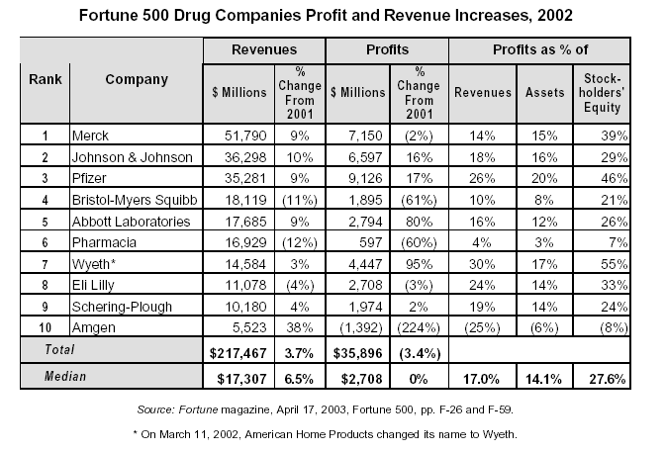
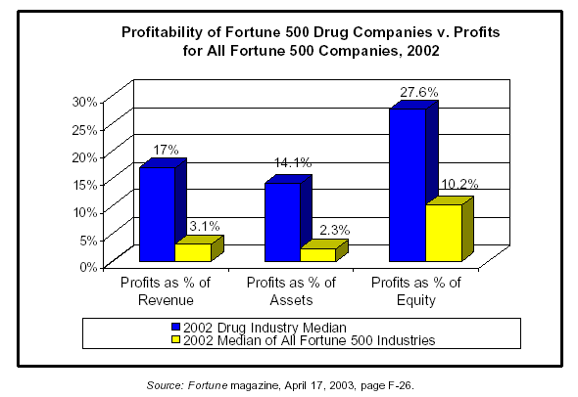

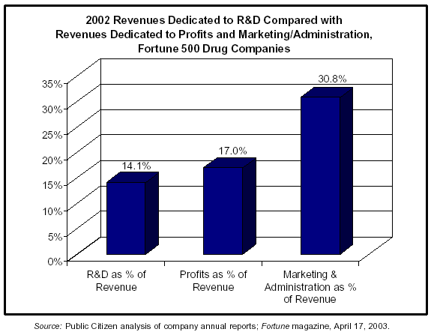

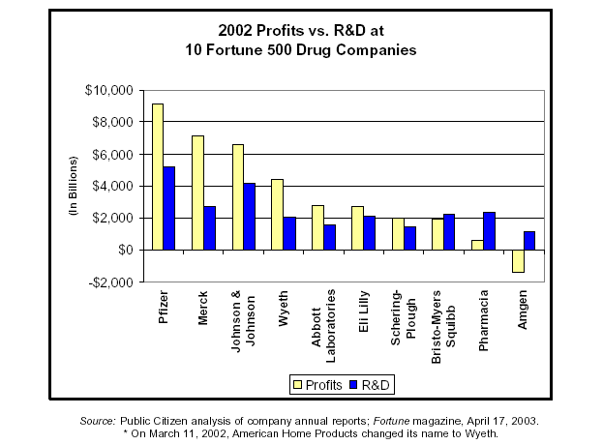

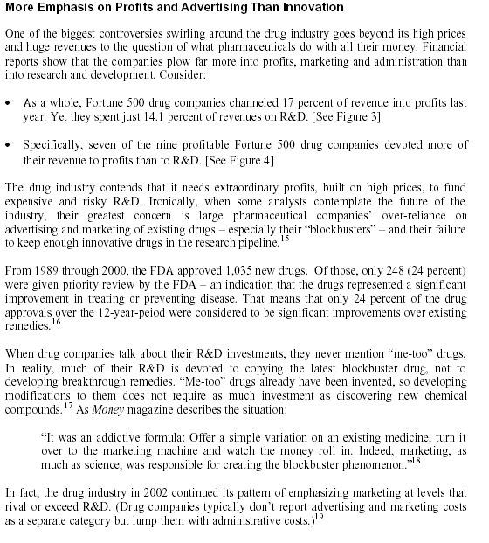
http://www.citizen.org/documents/Pharma_Report.pdf

The Accelerating Access Initiative (AAI)
Merck is a founding member of the UN/Industry Accelerating Access Initiative (AAI). Established in May 2000, AAI is a cooperative endeavor of UNAIDS, the World Health Organization, UNICEF, UNFPA and the World Bank, and several research-based pharmaceutical companies. Participants are committed to working with governments, international organizations and other stakeholders to find ways to broaden access while ensuring rational, affordable, safe and effective use of drugs for HIV infections and AIDS-related illnesses (Merck 2007).
To this end, a Joint Statement of Intent established shared principles and a common approach to accelerating access to HIV/AIDS care and treatment in developing countries:
- Political will and commitment of governments
- Strengthened national health care capacity
- Safe, secure and efficient distribution systems
- Involvement of all sectors of society
- Significant additional funding from both national and international sources
- Continued investment in research and development by the pharmaceutical industry
Merck has made a strong commitment to participating in the AAI, and is a signatory to the Statement of Intent. We work closely with the UN and other agencies to respond to particular needs of different countries, in a way and at a pace that makes sense to the country officials who have primary responsibility for the health of their populations (Merck 2007).
These efforts are beginning to bear fruit. As of September 2006, more than 738,000 HIV patients in developing countries had received ARV treatment at significantly reduced prices through the efforts of AAI companies. The AAI focused initially on Africa, where more than 424,000 people are being treated with at least one antiretroviral supplied by an AAI company, an increase of 11 percent over 12 months. This increase results in a 45-fold increase in the number of people being treated with medicines supplied by the AAI companies in Africa since the establishment of the AAI in May 2000 ( Merck 2007).

Ethics: Impacts of AIDS

The number of AIDS orphans is projected to exceed 25 million by the end of the decade
Taken from http://www.unaids.org/en/Issues/Affected_communities/orphans.asp

Some of the socio-cultural issues and impacts of AIDS are the stigmas that come with having AIDS especially in the gay community. Although, the early cases of AIDS in North America were seen largely among men who had sex with men, trends of infection have changed significantly over the course of the epidemic. In 1987, 78% of HIV+ diagnoses in BC were linked to men who had sex with men, but by 2001 this figure had dropped to 21%. In 2005, the rate had increased somewhat to 45%. By contrast, in 1987 heterosexual transmission accounted for only 3% of cases of HIV infection in BC, but by 2001, this rate had soared to 21%. In 2005, the statistics were 32%. For more information visit www.endhivstigma.ca.
Other important issues include the opportunistic diseases and infections that result from HIV. These include acute encephalitis, non-bacterial meningitis, tuberculosis, cerebral toxoplasmosis, pneumonia, wasting syndrome, cancer Kaposi’s’ sarcoma, and intestinal infections (Avert, 2007)

Another impact of AIDS is the orphans. These children face many problems including emotional problems, household impacts where to live what to eat, etc. The stigma that comes with having a parent die from AIDS and in many cases having been infected by their parents. Education; if they even are able to attend school at all they often perform poorly due to their situation (Avert, 2007) some 15 million children under age 18 have lost one or both parents to AIDS. The vast majority—more than 12 million—are in sub-Saharan Africa.

Evidence shows that AIDS orphans living with extended families or in foster care are frequently subject to discrimination and are less likely to receive health, education and other needed services. The situation is yet more desperate for those living in child-headed households or on their own on the streets.

The vulnerability of these children represents part of a vicious cycle: their circumstances put them at high risk for exploitation and abuse, and therefore exposure themselves to HIV, and lack of access to health care, education and social support perpetuates the conditions of poverty (UNAIDS, 2007).

Hi Queer For more information About AIDS stigmas.

Whose children are they now? This video talks about AIDS orphans in Ethiopia

Some Attempts at a Solution

MSF provides medical care wherever needed

Join Red “All things being Equal. They are not”

UNAIDS is committed to strengthening support to nationally owned and led responses.

The Global Fund was created to finance a dramatic turn-around in the fight against AIDS, tuberculosis and malaria. These diseases kill over 6 million people each year, and the numbers are growing.

The Bill and Melinda Gates Foundation. The foundation is guided by the belief that all lives, no matter where they are lived, have equal value. The mission of our Global Health program is to encourage the development of lifesaving medical advances and to help ensure they reach the people who are disproportionately affected. We focus our funding in two main areas:

Access to existing vaccines, drugs, and other tools to fight diseases common in developing countries.

Research to develop health solutions that are effective, affordable, and practical.

PEPFAR The United States President’s Emergency Plan for AIDS relief. The Emergency Plan is the largest commitment ever by any nation for an international health initiative dedicated to a single disease -- a five-year, $15 billion, and multifaceted approach to combating the disease around the world. The United States now leads the world in its level of support for the fight against HIV/AIDS.

Proposed Solution

We understand the intricacies of this issue and recognize after the research we looked into that patents have positive effects and agree that pharmaceutical companies have the right to profit from their inventions and work. However, our solution is for them to increase the aid they provide to the epidemic be it in research for a cure, education, prevention, but most importantly we agree that their prices should be limited and regulated. The market cannot control the prices, that is fine for cars, clothes, and any other consumer products but not for life-saving medications. Bottom line we need to value human ethics over economical gains. Due to growing science and technology over the years the emphasis on human well being has been shifted to a business and monetary well being. We propose that it is important to create personal solutions like having a sense of place in the world so that you can understand other people’s circumstances and needs, getting actively involved or even donating resources and wealth to the relief effort of underdeveloped countries.

Conclusion

“I believe that this could very well be looked back on as the sin of our generation. I look at my parents and ask, where were they during the civil rights movement? I look at my grandparents and ask, what were they doing when the holocaust in Europe was occurring with regard to the Jews, and why didn't they speak up? And when we think of our great, great, great-grandparents, we think how could they have sat by and allowed slavery to exist? And I believe that our children and their children, 40 or 50 years from now, are going to ask me, what did you do while 40 million children became orphans in Africa?"
- Rich Stearns, President of World Vision, US

Who is World Vision

It is when we encounter things that challenge our human capacity for solutions that we for a moment remember we are just human not immortal creatures capable of anything. AIDS has been one of those moments in history when regardless of race, color, religion, or background we have had to come together to try to find a solution. We believe pharmaceutical companies have done a great job and we are indebted to them in this fight but it is not enough. They have to recognize that they can do more. If there are medications available and someone, just one person not being able to access them, then we are not doing enough. We cannot look at this from the perspective of percentages or statistics we have to look at it from the perspective of a mother who loses her child to AIDS or a baby who will not have a mother or a father to care for him and love him due to AIDS. Over 25 million people have already died from AIDS all over the world. How many more have to die for us to stop it?

We would like to dedicate our project to the millions of people that fight the battle of AIDS everyday
and hope that their fight is made easier everyday.

About Us



Our names are Rachel Kohn, Julieth Monroy and Greg Sorrells. We all students in Dr. Nora Demers Issues in Science and Technology class IDS 3303 at Florida Gulf Coast University. We chose to research and expand on this topic mainly from an ethical standpoint due to our majors and backgrounds. Rachel is a psychology major, Julieth is a philosophy major with an economics minor, and Greg is an English major. To learn more about all of the assignments that led up to this final project you can visit Dr. Nora Demers’ website.

Our Research

Links to Assignments

Essay # 1

Outline

Timeline

Mining Resources
Annotated Bibliography

