Running Head: High Stakes Testing

High Stakes Testing: Incomplete Indicator for Student Retention
Cathie A. Muir
Florida Gulf Coast University

High Stakes Testing: Incomplete Indicator for Student Retention
Public education in the United States goes through a cycle of reform approximately every ten to twenty years. It takes several years for implementation of the reforms to catch up with the research that spawned its inception. Currently, the most pressing issue in education is how to hold our schools, teachers and students accountable for the information being taught in the classroom. Often, reform has come as a result of political and or societal pressure, as has been the case with the current accountability movement. When the federal government became involved, standardized tests that children had been taking for decades, suddenly turned into high stakes tests due to the use of testing data (Executive Summary, 2004). Increasingly, states have been using the scores from standardized tests to determine grade promotion and high school graduation (State Education Reforms, 2005). In light of the increased pressure being asserted on schools, teachers and students, it seems appropriate to consider the consequences of using high stakes testing to determine if a child is going to be promoted to the next grade and whether or not a student will receive a high school diploma after completing 12th grade. Given the many variables associated with high stakes tests, I feel student promotion and/or retention should not be based solely, or even primarily, on the results of standardized, high stakes tests, but rather on a combination of test scores, classroom performance and teacher assessments.
Testing is not a new phenomenon. Aptitude tests date back as far as 2200 B.C. when Chinese emperors used them to select civil servants (Machek, 2004). In subsequent years, China developed written tests, although the exact dates are not available (Black, 1998). Standardized tests evolved over the years. In Cleveland, Ohio, standardized tests were introduced by educational researchers in 1914 after 10,000 students in elementary schools failed to be promoted and studies concluded the teachers were not adequately measuring student performance (Giordano, 2005). The largest breakthrough in standardized testing occurred in 1917, however, when the United States Army, upon entering WWI, realized it was unable to assess the intellectual ability of its recruits. A committee of psychologists, chaired by Army officer Robert Yerkes, designed the Army Alpha and Beta tests that lay the groundwork for future standardized tests (Sass, 2005). The Alpha test had 212 questions which were to be answered by checking or underlining which permitted the tests to be scored using stencils. The test could be administered to 200 soldiers in less than one hour (Giordano, 2005). The Alpha test was the first large-scale use of multiple choice items, a technological feat. The Army was able to compare test scores of individual recruits against the performances of a norm group (Popham et al, 2001). When WWI ended, the psychologist who created the Alpha and Beta tests were discharged; many of them went to work for school systems which utilized their knowledge of standardized testing to create tests for their schools (Giordano, 2005). In 1935, the standards movement in the United States began to emerge as a solution to the public’s demand for scholastic accountability. The push to set and enforce teaching standards meshed well with the emphasis being placed on standardized tests (Giordano, 2005).
Concern in the United States mounted after the Soviet launch of Sputnik as it became clear that the students from other countries were excelling in math and science at a greater rate than U.S. students. Congress passed the National Defense Education Act (NDEA) in 1958 which placed an emphasis on improving science, math, and foreign language instruction in elementary and secondary schools (The Federal Role in Education, 2006). This financial support made it possible for states to launch large scale testing programs through the use of standardized tests (Heubert et al, 1999). At this point, the federal government was not involved in the testing, they merely provided the financial resources to make testing in all states possible.
On April 26, 1983, the National Commission on Excellence in Education produced a report titled A Nation at Risk (NAR) which indicated the urgent need for widespread reform in the public education system (Phillips et al, 2004). The commission stated the reform was warranted due to markedly declining standardized test scores of American students during the 1960s and 1970s. American students performed poorly on standardized tests when compared with students from other countries (Giordano, 2005). The report cited two new threats facing the nation; global competition and the changing economic foundation (Phillips et al, 2004). This new research highlighted a need for accountability reforms. Businesses and state governments began demanding proof that students graduating from high school possessed the necessary skills to work in the ever changing global society that the United States had fast become (Alwerger, et al, 2002).
Prior to the dissemination of the NAR report, standardized tests had been used by states and school districts to compare individual student’s scores with those of other students across the nation for academic evaluation purposes (FASP Position Paper, 2006). Schools were not using the tests for determining student ability and were not attaching the scores to student promotion or retention. At the same time, businesses had been complaining that the public schools were churning out employees incapable of what they considered to be the basic fundamentals of grammar and math (Altwerger, et al, 2002). Social promotion, the act of permitting a student to move on to the next grade even if he/she has not met the necessary academic requirements, held a prominent role in education policy even though few statistics regarding this practice are available (Heubert et al, 1999). It appears that the wave of public opinion was beginning to change and the community was at the very cusp of the use of standardized tests to determine student progression in school.
In 1983, Florida was the first state to require students pass the state’s high stakes graduation test to secure a diploma (Position Paper, 2006). Congress authorized the National Assessment of Educational Progress (NAEP) in 1966 which would go on to provide state-by-state comparisons of student achievement in math, reading, writing and science (Giordano, 2005). The NAEP has come to be called the Nation’s Report Card as a result of its testing and reporting practices (The Nation’s Report Card, 2006). By the middle of the 1990s, a greater emphasis had been placed on statewide testing to determine academic achievement, and by 1995, forty-three states were conducting these tests (Jones et al, 2003). Former President Bill Clinton challenged the nation in his State of the Union Address “to undertake’ a national crusade for education standards – not federal government standards, but national standards, representing what all our students must know to succeed in the knowledge economy of the twenty-first century. . . Every state should adopt high national standards, and by 1999, every state should test every fourth-grader in reading and every eight-grader in math to make sure these standards are met. . . They can help us to end social promotion. For no child should move from grade school to junior high, or junior high to high school until he or she is ready’” (Heubert et al, 1999).
In a sweeping act of educational reform, President George W. Bush signed the No Child Left Behind Act (NCLB) into law in 2002. NCLB was created to ensure the neediest children did not fall between the cracks of failing schools, often going unnoticed. The new law increased accountability for states requiring them to set up curriculum standards, and mandated testing of all students in grades 3-8. Additionally, schools were required to make adequate yearly progress or face restructuring measures to get them in alignment with state standards. NCLB gave parents of students who attended low performing schools more choices of public schools their children could attend. Through the Elementary and Secondary Education Act, federal aid to disadvantaged children was made available through the Title 1 program to address problems of students living in poor urban and rural areas (The Federal Role in Education, 2006). NCLB allowed states more flexibility in the use of federal funding made available through Title 1. The federal act also placed a greater emphasis on reading than had been required previously. In order for states to continue receiving federal funding for public schools, they were required to subject their students to high stakes testing and report the results to the federal government (Executive Summary, 2004).
In response to growing anxiety that U.S. students were not performing at the level appropriate for their age; individual states have begun to attach high stakes to the standardized test scores. Currently, twenty-four states require students pass a state-mandated standardized test to graduate from high school and nine states require students to pass state-mandated tests at specific grade levels to be promoted to the next grade (State Education Reforms, 2005). In 2004, 20% of third graders in New York, who had already been retained once, failed to pass the state test again which meant they remained in the third grade for their third year (Lucadamo, 2004). Also in 2004, 20,000 Florida third-graders failed to pass the FCAT and were retained, several thousand for a second time (Matus, 2005).
Student failure on high stakes testing has far reaching effects for the school, the teachers and the children. School administrators, under increasing pressure to meet the rigorous Adequate Yearly Progress (AYP) benchmarks of the NCLBA, have begun placing pressure on teachers to increase student performance on high stakes tests, as their job security has increasingly become tied to student performance (Dobbs, 2003). (I have charts that go with the AYP for each state, however, I have been unable to move them from pdf files to Word) Teachers have been teaching only information they know will be on the test, compromising the education their students receive. Subjects such as science and social studies have been dropped and skills such as learning to write a research paper have been eliminated to ensure teachers have enough time to teach the information that will be presented on the test (The Dangerous Consequences of High-Stakes Standardized Testing). Teaching to the test has become a reality in schools across the country as “Teachers are warned that their raises, bonuses or even their jobs are on the line” (Bracey, 2000). There have been cases reported in several states of teachers and administrators who give students answers, assist students in rewriting essays, changing identification numbers of low-achieving students whose scores they don’t want counted in the school report, erasing answers after tests are turned in and replacing them with correct answers, telling low performing students it is acceptable to stay home on test days and encouraging low achieving students to drop out of school, eliminating their scores from the school’s report completely (Jones et al, 2003). Students whose tests have been altered are able to move to the next grade, but the report results are no longer accurate or reliable. Under pressure to show results, Texas administrators changed withdrawal codes, such as indicating a student moved to a private school rather than dropping out, for at least thirty students from Sharpstown High School to make it appear that no one had dropped out of the school within the 2001-2202 school year (Dobbs, 2003). Principals had an incentive to ensure the dropout rates of their schools were low. Schools reporting a dropout rate of less than 0.5 percent ensured principals an increase in their chances of winning bonuses of as much as $10,000 and earning top ratings for their schools (Dobbs, 2003). Students who continue to fail their tests are retained, sometimes, as has occurred in the state of Florida, for two more years before they are moved on to the fourth grade. Due to increased test preparation, subjects such as art, music and physical education are often reduced or completely eliminated from the school schedule which further inhibits the child’s education (Peterson et al, 2003).

Table 2
Rates at Which Students Did Not Graduate or Receive a High School Diploma Due to Failing the State High School Graduation Exam (Note 75)
State (Note 76) | Grade in which students first take the exam | Percent of students who did not  graduate or receive a regular  high school diploma because they  did not meet the graduation requirement (Note 77) | Year
Alabama* | 10 | 5.5% | 2001
Florida* | 11 | 5.5% | 1999
Georgia* | 11 | 12% | 2001
Indiana* | 10 | 2% | 2000
Louisiana | 10 & 11 | 4% | 2001
Maryland | 6 | 4% | 2000
Minnesota | 8 | 2% | 2001
Mississippi* | 11 | n/a (Note 78) | n/a
Nevada | 11 | 3% | 2001
New Jersey | 11 | 6% | 2001
New Mexico* | 10 | n/a | n/a
New York | n/a (Note 79) | 10% | 2000
North Carolina* | 9 (Note 80) | 7% | 2000
Ohio | 8 | 2% | 2000
South Carolina | 10 | 8% | 1999
Tennessee | 9 | 2.5% | 2001
Texas | 10 | 2% | 2001
Virginia* | 6 | 0.5% | 2001

The effects of high-stakes tests on learning were measured by examining indicators of student learning, academic accomplishment and achievement other than the tests associated with high-stakes. These other indicators of student learning serve as the transfer measures that can answer our question about whether high-stakes tests show merely training effects, or show transfer of learning effects, as well. The four different measures we used to assess transfer in each of the states with the highest stakes were:
- the ACT, administered by the American College Testing program;
- the SAT, the Scholastic Achievement Test, administered by the College Board;
- the NAEP, the National Assessment of Educational Progress, under the direction of the National Center for Education Statistics and the National Assessment Governing Board; and
- the AP exams, the Advanced Placement examination scores, administered by the College Board.
In each state, for each test, participation rates in the testing programs were also examined since these vary from state-to-state and influence the interpretation of the scores a state might attain.

Table 1
Consequences/"Stakes" in K–12 Testing Policies in States that
Have Developed Tests with the Highest Stakes (Note 64)
States | Total Stakes | Grad. examª | Grade prom. exam^{b} | Public report cards^{c} | Id. low perform.^{d} | $ awards to schools^{e} | $ awards to staff^{f} | State may close low perform.^{g} | State may replace staff^{h} | Students may enroll else- where^{i} | $ awards to students^{j}
Alabama | 6 | X |  | X | X | X |  | X | X
Florida | 6 | X |  | X | X | X | X |  |  | X
Georgia | 5 | X | 2004 (Note 65) | X | X | X | X | 2004
Indiana | 6 | X |  | X | X | X |  | X |  | X
Louisiana | 7 | X | X (Note 66) | X | X |  |  | X | X | X
Maryland | 6 | X |  | X | X | X |  | X | X
Minnesota | 2 | X |  | X
Mississippi | 3 | X |  | X | X | 2003 |  | 2003
Nevada | 6 | X |  | X | X |  |  | X | X |  | X
New Jersey | 4 | X |  | X | X | X
New Mexico | 7 | X | X (Note 67) | X | X | X |  | X | X
New York | 5 | X |  | X | X |  |  | X | X
North Carolina | 8 | X | X (Note 68) | X | X | X | X | X | X (Note 69)
Ohio | 6 | X | 2002 (Note 70) | X | X | X | X |  |  |  | X
South Carolina | 6 | X | 2002 (Note 71) | X | X | X |  | X | X
Tennessee | 6 | X |  | X | X | X | X | X
Texas | 8 | X | 2003 (Note 72) | X | X | X | X | X | X (Note 73) | X
Virginia | 4 | X |  | X | X |  |  | X

ªGraduation contingent on high school grad. exam.
^{b}Grade promotion contingent on exam.
^{c}State publishes annual school or district report cards.
^{d}State rates or identifies low performing schools according to whether they meet state standards or improve each year.
^{e}Monetary awards given to high performing or improving schools.
^{f}Monetary awards can be used for "staff" bonuses.
^{g}State has the authority to close, reconstitute, revoke a school's accred. or takeover low performing schools.
^{h}State has the authority to replace school personnel due to low test scores.
^{i}State permits students in failing schools to enroll elsewhere.
^{j}Monetary awards or scholarships for in- or out of state college tuition are given to high performing students.
These states have not only the most severe consequences written into their K–12 testing policies but lead the nation in incidences of school closures, school interventions, state takeovers, teacher/administrator dismissals, etc., and this has occurred, at least in part, because of low test scores. (Note 74) Further, these states have the most stringent K–8 promotion/retention policies and high school graduation exam policies. They are the only states in which students are being retained in grade because of failing state tests and in which high school students are being denied regular high school diplomas, or are simply not graduating, because they have not passed the state's high school graduation exam. These data on denial of high school diplomas are presented in Table 2.
(I am still trying to locate the citation for the graphs in this set. When I copied them from the internet, I neglected to copy the web address like I normally do. I will be sure to have the citations prior to my presentation and final paper).
The 9th grade bulge has become an increasing concern. Schools are retaining academically weaker 9th graders in an effort to improve their test scores the following year on the 10th grade national test. Some students are being retained in 9th grade for three years then moved to the 11th grade, completely skipping 10th grade, thereby no longer eligible to take the national test which would have reduced the school’s scores. One of the tactics school districts are using to cover their dropout rates is to retain 9th graders until they reach the age of sixteen when they are legally eligible to dropout of school without parental permission. These students become so discouraged, dropping out seems to them to be the best alternative to spending another year in 9th grade (Dobbs, 2003). As the Vice Principal of one Texas high school reported, “The secret of doing well in the 10th grade tests is not to let the problem kids get to the 10th grade” (Dobbs, 2003). Former Secretary of Education, Rod Paige, also the former Houston school superintendent, remarks that the sharp increase in 9th grade enrollment and the equally sharp drop in subsequent grades is a national phenomenon (Dobbs, 2003). A study conducted by Boston College researchers in 2004 which was conducted for the National Board of Educational Testing and Public Policy concluded that the number of students being retained in the 9th grade has nearly tripled since the late 1960s (Goldberg, 2005).
Perhaps the most concerning issue for students are the studies which indicate the probability that a student will drop out of school increases by 50% for students who are retained one time and rise as high as 90% for those held back twice (Thomas et al, 2005). A study conducted by the Center for Social Organization of Schools at Johns Hopkins University indicated that 2,000 high schools in the United States have dropout rates of 40 percent or higher. Many of those students dropout of school in grades 9 or 10 after failing high stakes tests and reaching the legal age to leave school without parental permission (Goldberg, 2005).
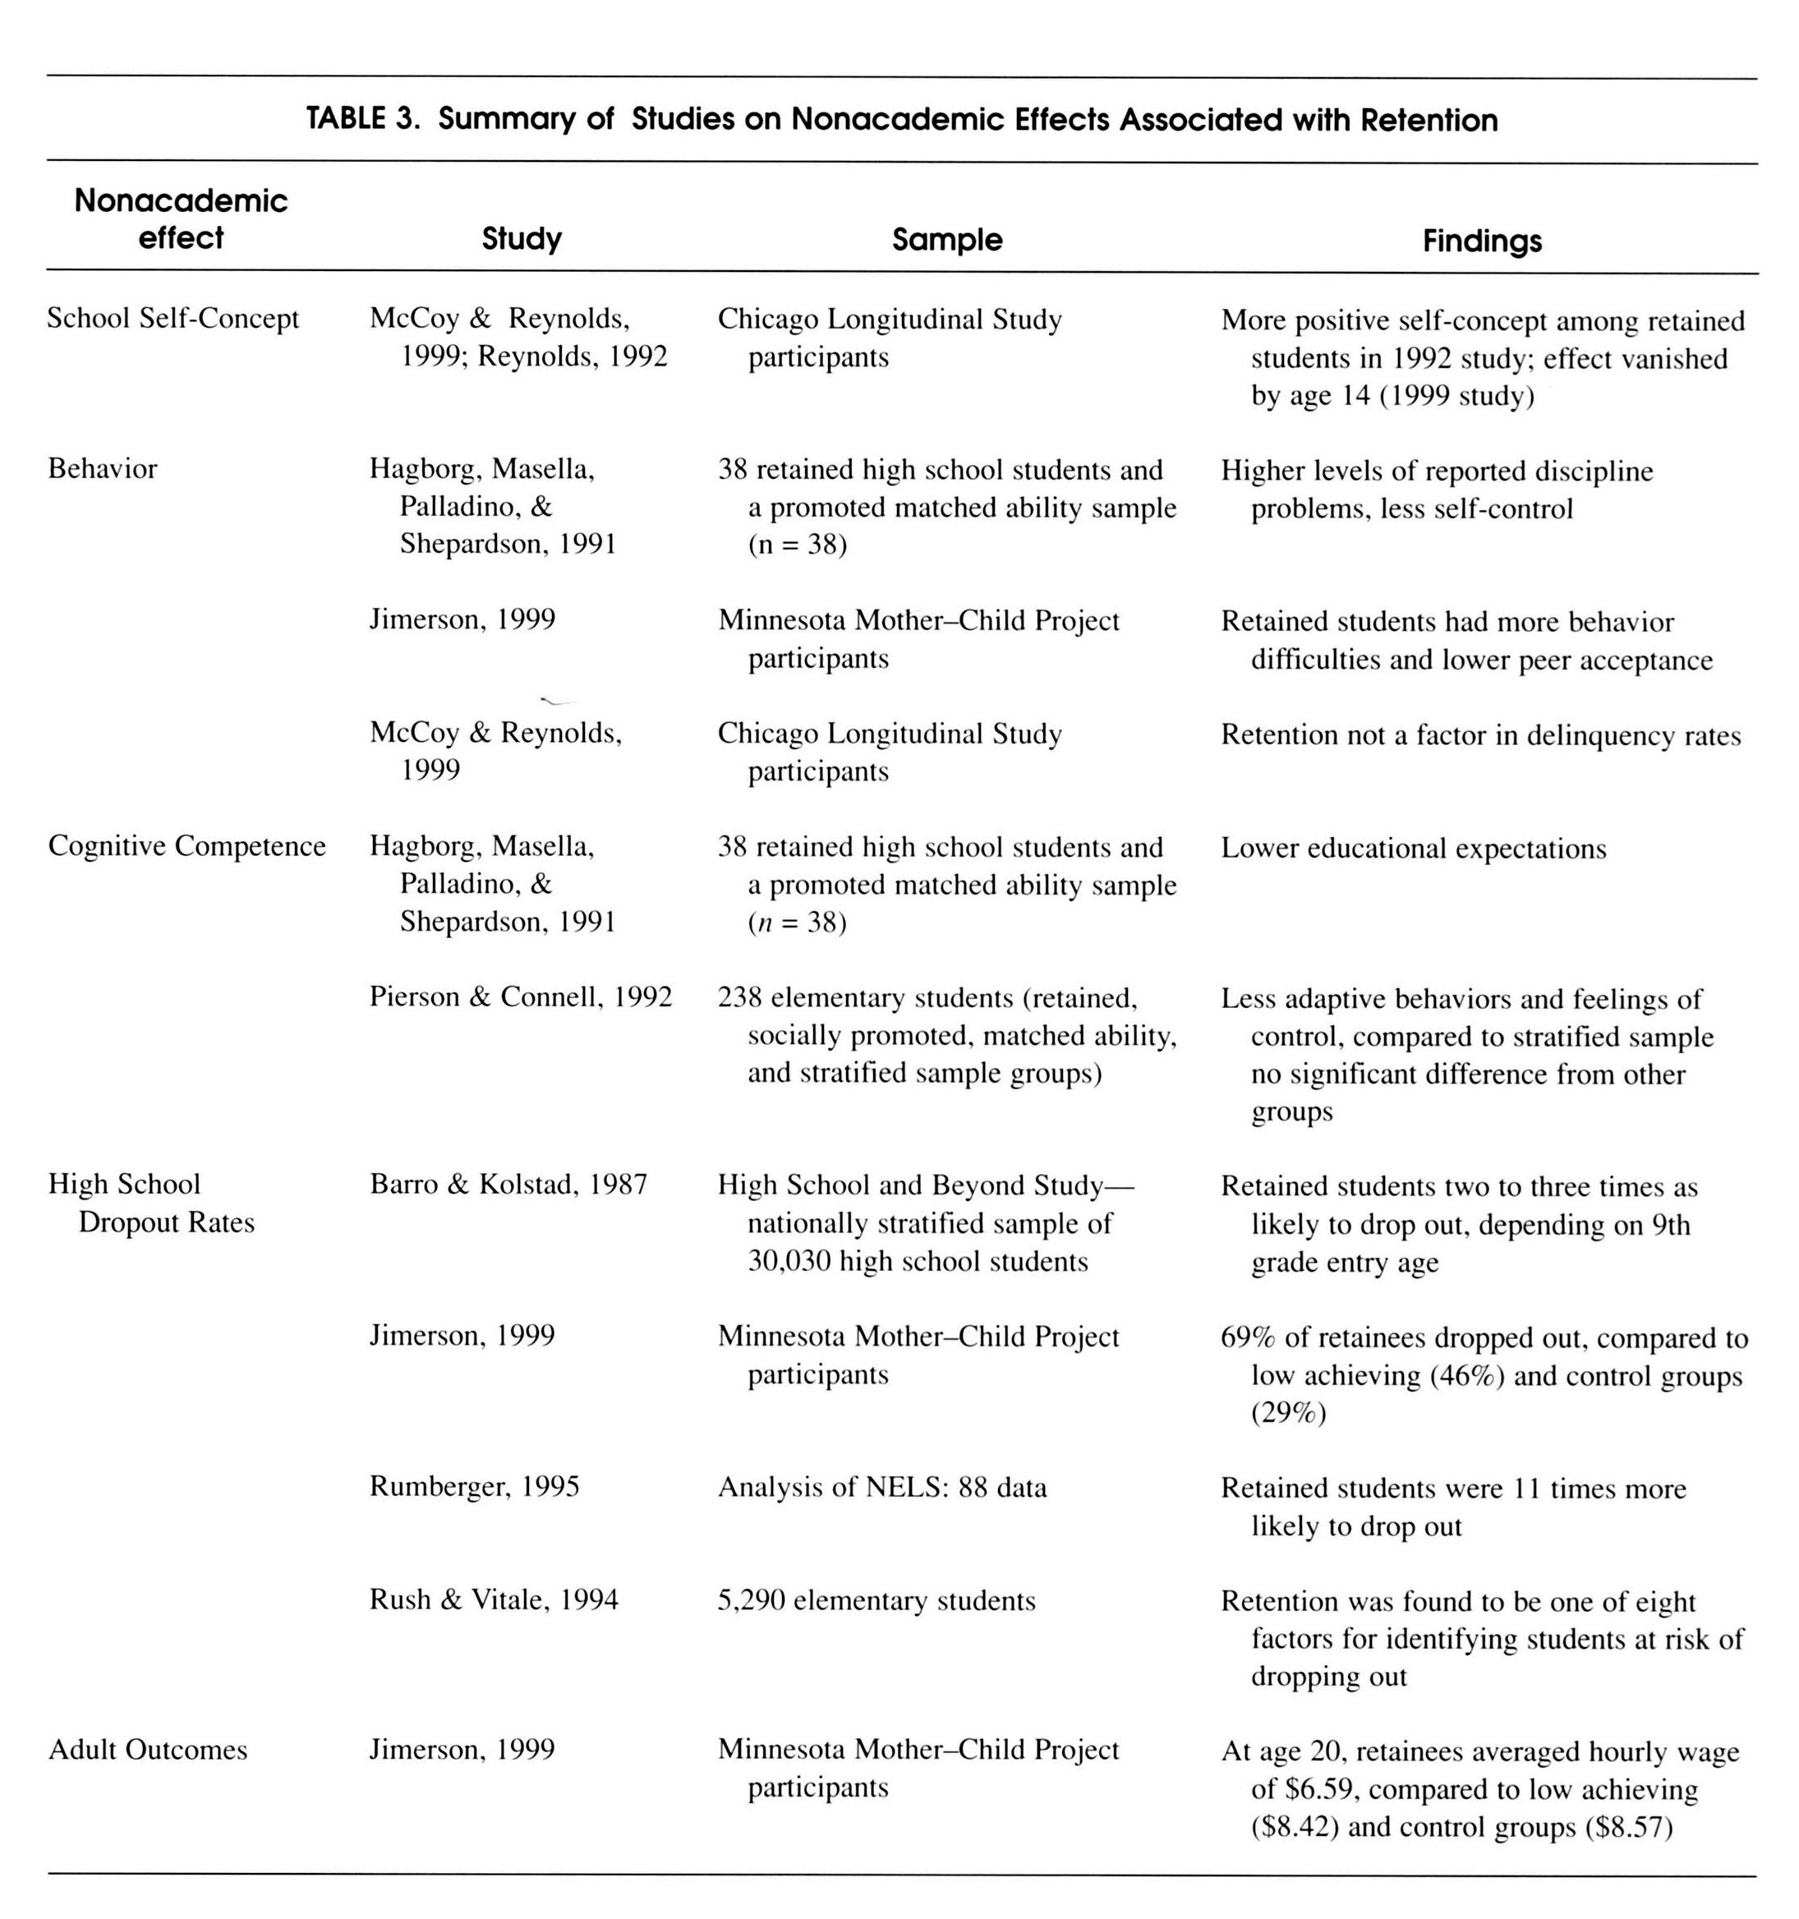

http://proquest.umi.com.ezproxy.fgcu.edu/pqdlink?did=938665291&Fmt=7&clientId=8631&RQT=309&VName=PQD

As demonstrated in the chart below, there are many consequences associated with student retention. One study noted that student showed short-term gains in math, however, the gain disappeared by the time they were in sixth grade and they adjusted poorly to social situations through the age of 16. A study by Karweit in 1999, revealed that while same-grade retention proved to have positive effects during the retention year, these effects were not sustained over time. Another study of over 12,000 students conducted by Resnick et al, in 1997 showed that retention was associated with emotional distress and tobacco use in middle school aged children. (I just discovered that the web address I recorded for these charts does not lead me directly to the site so I will have to go back to my sources to find the exact location of this data).
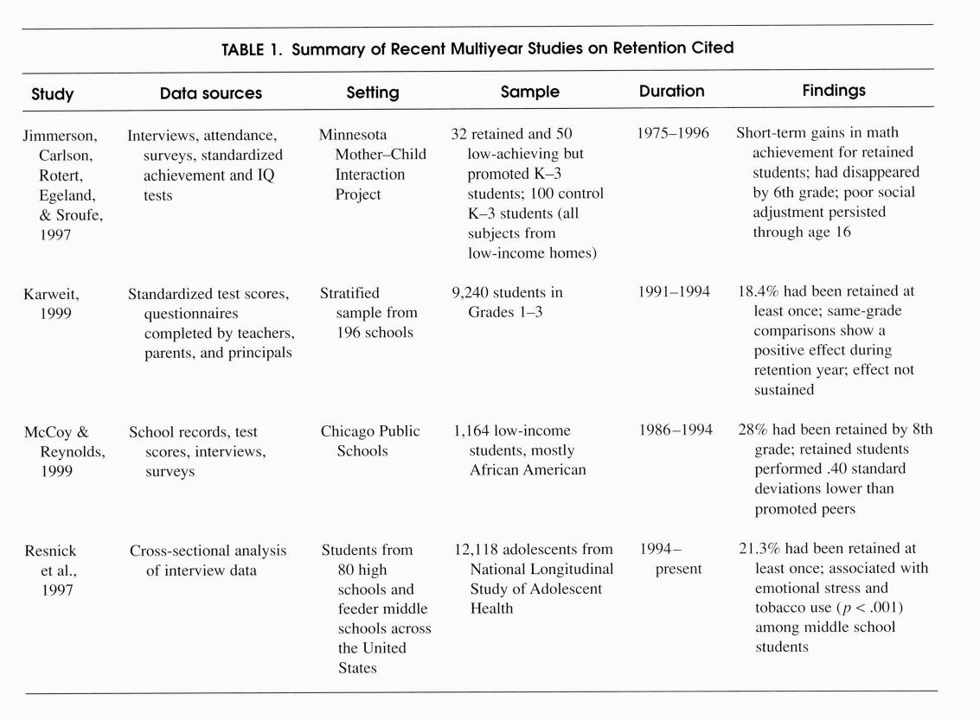

http://proquest.umi.com.ezproxy.fgcu.edu/pqdlink?did=938665291&Fmt=7&clientId=8631&RQT=309&VName=PQD

Those who defend high stakes testing view the negative publicity as unsubstantiated rhetoric. Richard Phelps claims that public support for high stakes testing is consistent and that the majority of Americans support these tests (2005). Gregory J. Cizek, a contributing author in Defending Standardized Testing, cites testimonials from a major book, Improving Schools by Standardized Tests, with quotes from teachers who claim the children “. . . look forward eagerly to the testing time”, and “. . . instead of dreading an ‘examination’ as they used to do, they are simply overjoyed at the prospect of taking a ‘test’”. Additionally, these teachers express their support of standardized tests with comments such as “My appreciation for having had the privilege of introducing standardized tests in my school cannot be too strongly emphasized . . .” and “I now consider standardized tests the only fair means of measuring a pupil’s ability and progress . . .” (Phelps et al, 2005). One might think that these teachers had been engaging in mind-altering substances to make such statements until reading further to find out Improving Schools by Standardized Tests was written in 1922; the author admits “. . . perceptions about testing have changed somewhat since that time . . .” (Phelps et al, 2005).
Complaints over the accuracy of the test grading process have increased even as technology improves. Reports of teachers allowing students to practice on the previous year’s exam which contained some of the questions used on the current year’s test surfaced in New York City (Goldberg, 2005). Additionally, it was discovered that questions were displayed on a local TV channel prior to the exam date and the answer sheet from the publisher of one exam did not match the test booklet (Goldberg, 2005). One educator cautions that tests are a very inaccurate reflection of student performance at the low and high scoring ends of the spectrum as this is the area where the margin of error is greatest (Gewertz, 2004). Some states lower the standards by which they are graded by manipulating the methods by which the data are reported (Gryphon, 2005).
Cameron Fortner, a Stanford University graduate, spent a summer as a test-scorer for a Boston testing company. His experience as a test-scorer reinforces the question of accuracy in the grading of high stakes tests. He received three days of training where he was taught the scoring rubric and numerical scoring system for the essay portion of a standardized test. Fortner reports that all of the scorers were temps, even the supervisors, many lacked a college degree, some had poor English skills, and the turn-over rate was very high due to low compensation. He laments the fact that committees using the test scores his fellow employees cared so little about are being used to make decisions about the futures of individual students, as well as which schools receive a failing grade and how teachers’ salaries would be affected. Cameron Fortner concluded that if most standardized tests are scored in a manner consistent with the one in which he was involved, then he does not put much stock in the test results (2001). The Denver Post ran a story about Kelly Services, a temporary job placement company that was looking for more than 700 temporary workers to grade standardized achievement tests for Measured Progress, a New Hampshire testing company. The job ran for slightly over one month and paid $11.00 per hour. The applicants did not need to have any experience grading tests, but were required to have at least an associate’s degree. The temporary employees were to grade reading, writing and math assessment tests (Svaldi, 2005). With such low wages and short employment period, it seems rather unlikely that Kelly Services acquired top-notch graders whose grading results had the capacity to greatly impact the futures of children in gate-way grades, not to mention teachers and administrators.
Technology is playing an important role in the future of high stakes grading. Most tests are composed of multiple choice items which are easily graded by a computer. Increasingly, states are requiring tests that include higher order thinking skills, which means that students will have to write more essays. One software program, Intelligent Essay Assessor, is being considered by testing companies to reduce costs and human error in grading student essays. Currently, the technology is not reliable enough to be used on high stakes tests, but technology is moving toward a time when a computer program will replace one of the two human graders, making the grading system more efficient and less costly (Johnson, 2003).
Those who defend high stakes testing dismiss the implication that the grading systems could be faulty resulting in students being retained erroneously. Gregory Cizek compares the accuracy of high stakes testing with that of DNA tests, “Even with the miraculous DNA tests, experts can only make statement like ‘there is 99.93% chance that the DNA is a match’” (Phelps, 2005). Proponents of high stakes tests, such as Governor Jeb Bush, consider the measures being taken to raise accountability in schools essential to meeting the demands of the changing global marketplace: “If we don’t move forward, we’re going to be gobbled up by competitors in far-off places” (Cotterell, 2006). Harvard professor Paul Peterson analyzed Florida’s accountability system and claims “Florida looks pretty good. There are few states that have a record that is this consistent” (Matus, 2006).
Jay Greene and Marcus Winters conducted a study of Florida’s program to end social promotion through the Manhattan Institute for Policy Research. They analyzed one year of test score gains for third grade students on state-mandated (FCAT) reading and math tests. The researchers compared the scores from the FCAT test with those of the Stanford-9 standardized test to which no high stakes were attached. Their research found that the performance of students who were either retained or subject to the retention policy (even if they had been provided a waiver and promoted to 4th grade), exceeded the performance of students who were not retained or subject to the retention policy. They also found their results were consistent with the low-stakes Stanford-9 test (Greene, 2004). Greene and Winters found that “The results of our analyses are encouraging for the use of objective retention policies based on the results of standardized tests. Each of our analyses found consistently positive results for the use of such retention policies” (2004). The researchers conclude that the more important question of the retention policy effects over a period of time was not answered in their limited analysis and that the same students would need to be followed throughout their academic careers to discover whether the gains made by the students accumulate, recede or remain consistent (Greene, 2004).
Education Working Paper No. 7 December 2004

An Evaluation of Florida’s Program to End Social Promotion
Table 7: Effect of Retention on FCAT Reading Test
 | Effect on FCAT Reading Test | Standard Error | P-Value
Student Was Retained | 32.48 | 3.80 | 0.0000
American Indian | 2.44 | 20.18 | 0.9040
Asian or Pacific Islander | 37.51 | 9.71 | 0.0001
Hispanic | -3.66 | 3.22 | 0.2555
Multiracial | 14.69 | 7.35 | 0.0458
Black, Non-Hispanic | -39.65 | 2.52 | 0.0000
Receives Either Free or Reduced-Price Lunch | -56.42 | 2.44 | 0.0000
Student Is Limited English Proficient | -1.41 | 2.88 | 0.6260
Baseline FCAT Reading Test Score | -0.48 | 0.00 | 0.0000
Adjusted R-Squared | 0.159
N | 89397
http://www.manhattan-institute.org/html/ewp_07_t07.htm
The Florida Department of Education makes a link about FCAT Myths vs. Facts available to the public (FCAT Myths vs. Facts). The paper seeks to answer the predominant questions about high stakes testing such as: The FCAT administration takes too much time away from instruction; The FCAT is requiring teachers to “teach to the test”; The FCAT is biased against minority students; Students must pass the FCAT in each grade level to be promoted to the next grade; Teacher’s paychecks depend on their students’ good performance on the FCAT; the FCAT performance items are scored by people who are just “hired off the streets”, and several more for a total of fourteen questions (FCAT Myths vs. Facts). Clearly it is in the state’s best interest to spin information to their advantage and since there is not any way to address these items on the website, the reader is urged to take the state’s answers as the facts over the myths they have potentially heard from neighbors or the media. The answer provided for the statement that the FCAT requires too much instructional time is that it only takes about eight to ten hours over a number of days, less than one percent of the total time students are in school, to take the tests (FCAT Myths vs. Facts). In response to the concern that teachers teach to the test, the state claims that terminology means that “students are being taught exact questions on the FCAT” which is clearly “not desirable” and that teachers teach state standards which do not represent anything that is “unusual” in the curriculum (FCAT Myths vs. Facts). To the question of whether or not the FCAT is biased against minority students, the state claims that “all test questions are reviewed to make certain they are not biased against anyone. . . . There is no evidence of bias in these items.” They claim that some students simply do not perform well on the FCAT regardless of their ethnic origins because they have not yet learned the necessary reading, writing and math skills (FCAT Myths vs. Facts). In addressing parents’ largest concern, that students must pass the FCAT in each grade to be promoted to the next grade, the state flatly denies that allegation stating students must pass the FCAT in only two situations, the first is the Grade 10 test to qualify for a regular high school diploma and the second is in Grade 3 where students who have not demonstrated sufficient reading skills must be provided with additional instruction prior to being promoted to 4th grade (FCAT Myths vs. Facts). What the state fails to tell the reader is that the additional instruction is another year in the 3rd grade. The paper also fails to report that the state is seeking to have the law changed to require students at every grade level pass the FCAT prior to promotion (Matus, 2005). General Bill S1892 to revise laws relating to the FCAT died in committee on May 6, 2005 (Session Bills, 2006). And finally, the suggestion that teachers’ paychecks depend on their students’ good performance on the FCAT is addressed with the statement that “There is nothing in state law that ties a teacher’s pay to performance on the FCAT. . . The schedules take into account how well the teacher is performing in terms of student knowledge and skill, but the language does not mention the FCAT” (FCAT Myths vs. Facts). The state fails to mention the Effective Compensation or E-Comp plan in which the Legislature created performance pay for teachers in 2002 that would no longer pay teachers on the basis of experience or educational degree but rather based upon FCAT scores and other criteria. At this point in time, only teachers whose students take the FCAT are under the performance pay plan (Winchester, 2006).
There are many variables involved in the implementation, scoring and reporting of high stakes testing. For those reasons, it is irresponsible to base the decision of student in-grade retention and high school graduation on the basis of one test. Standardized tests are proven to be effective in many educational settings, however, as W. James Popham states so eloquently: “Standardized achievement tests should not be used to judge the quality of students’ schooling because factors other than instruction also influence students’ performance on these tests” (2001). The public educational system is losing excellent teachers who refuse to be labeled by the results of one test. Students are dropping out of school because they feel like failures. Schools must be accountable for the information they teach our students, and we must make sure the measure of their accountability is accurate and balanced.

Work Cited
Altwerger, B., Strauss S. L., Labbo L. D., and Bomer, R. (2002, Jan). The business behind testing. Language Arts, 79. Retrieved Jan 26, 2006.

Black, P. (1998). Testing: friend or foe? the theory and practice of assessment and testing. Washington, D.C.: The Falmer Press, 7-9, 13-18.

Bracey, G. (2000). High stakes testing. Retrieved Feb. 16, 2006, from EPSL Web site: www.asu.edu/educ/epsl/EPRU/documents/cerai-00-32.htm.

Cotterell, B. (2006). Governor wants tougher curricula for middle, high schools. Retrieved Feb. 16, 2006, from Tallahassee.com Web site: www.tdo.com/apps/pbcs.dll/article?AID=20060215/NEWS02/602150312/1010.

Dobbs, M. (2003). Scandal in an education 'miracle'. Retrieved Jan. 28, 2006, from MSNBC - Scandal in an education 'miracle' Web site: www.msnbc.msn.com/id/3403664.

Executive summary. (2004). Retrieved Feb. 18, 2006, from ED.gov Web site: http://www.ed.gov/nclb/overview/intro/execsumm.html.

Fcat myths vs. facts. (n.d.). Retrieved Feb. 24, 2006, from Florida Department of Education Web site: www.firn.edu/doe/sas/fcat/pdf/myths-facts.pdf.
Fortner, C. (2001). Who's scoring those high-stakes tests? poorly trained temps. The Christian Science Monitor, . Retrieved Jan 27, 2006, from www.csmonitor.com/2001/0918/p19s1-1ekt.htm.
Gewertz, C. (2004, June 16). Debate over retaining 3rd graders roils n.y.c.. Education Week, 23. Retrieved Jan 26, 2006,

Giordano, G. (2005). How testing came to dominate american schools. New York: Peter Lang,
23, 26, 58-59, 79, 86, 94, 126, 195, 203, 204, 206-209.

Goldberg, M. (2005, Jan ). Test mess 2: are we doing better a year later?. Phi Delta Kappan, 86. Retrieved Jan 26, 2006.
Gryphon, M. (2005). Education law encourages fuzzy math. Retrieved Jan. 27, 2006, from CATO.org Web site: www.cato.org/pub_display.php?pub_id=3694.
Greene, J. P. (2004). An evaluation of florida's program to end social promotion. Retrieved Jan. 26, 2006, from Education Working Paper 7 Web site: www.manhattan-institute.org/html/ewp_07.htm.

Heubert, J., & Hauser, R. (Eds.). (1999). High stakes testing for tracking, promotion, and graduation. Washington, D.C.: National Academy Press, 13-15, 41, 137.
Johnson, S. (2003). The write-stuff software. Retrieved Jan. 27, 2006, from Emerging Technology Web site: www.discover.com/issues/jun-03/departments/feattech.
Jones, M., Jones, B., & Hargrove, T. (2003). The unintended consequences of high-stakes testing. Lanham, MD: Rowman & Littlefield Publishers, Inc., 15-16, 71-72
Lucadamo, K. (2004). Kids face third try in 3rd grade. New York Daily News, . Retrieved Jan 27, 2006, from www.nydailynews.com/news/v-pfriendly/story/204013p-176083c.html.
Machek, G. (2004). Brief history of the measurement of intelligence. Retrieved Feb. 16, 2006, from Human Intelligence Web site: http://www.indiana.edu/~intell/intelligenceTests.shtm.
Matus, R. (2005). Board wants to end social promotion. St. Petersburg Times, . Retrieved Feb 27, 2006, from www.sptimes.com/2005/01/19/State/Board_wants_to_end.shtml.
Matus, R. (2006). Bush: school reform not over. Retrieved Feb. 16, 2006, from St. Petersburg Times Online Web site: www.sptimes.com/2006/01/25/news_pf/State/Bush_School_reform_n.shtml.
Nation's report card. (2006). Retrieved Feb. 17, 2006, from National Center for Education Statistics Web site: http://nces.ed.gov/nationsreportcard/.
Peterson, P., & West, M. (Eds.). (2003). No child left behind? the politics and practice of school accountability. Washington, DC: Brookings Institution Press, 64.
Phelps, R. (Ed.). (2005). Defending standardized testing. Mahwah, NJ: Lawrence Erlbaum Associates, Publishers, 13, 46.
Phillips, K. (2004). Testing controversy a rhetoric of educational reform. Cresskill, NJ: Hampton Press, Inc., 55.
Popham, W. (2001). The truth about testing an educator's call to action. Alexandria, VA: Association for Supervision and Curriculum Development, 40-42, 74.
Position paper on the use of florida comprehensive assessment test (fcat) in high stakes decision making. (n.d.). Retrieved Feb. 17, 2006, from FASP Web site: http://www.fasp.org/PDFfiles/FASP%20FCAT%20Paper.pdf.

Sass, E. (2005). American educational history: a hypertext timeline. Retrieved Feb. 17, 2006, from American Educational History Timeline Web site: http://www.cloudnet.com/~edrbsass/educationhistorytimeline.html.

Session bills. (2006). Retrieved Feb. 25, 2006, from The Florida Senate Web site: www.flsenate.gov/session/index.cfm?Mode=Bills&SubMenu=1&Tab=sessions&Bi_Mode.
State education reforms. (2005). Retrieved Jan. 27, 2006, from NCES Web site: http://nces.ed.gov/programs/statereform/saa/saa_tab8.asp?tblName=8&tableID=8&ReformID=1.
Svaldi, A. (2005). Staffing firm kelly services seeks temporary test graders. Retrieved Feb. 25, 2006, from ProQuest Web site: www.proquest.umi.com.ezproxy.fgcu.edu/pqdlink?vinst=PROD&fmt=3&startpage=-1&ver=1.
The dangerous consequences of high-stakes standardized testing. (n.d.). Retrieved Feb. 11, 2006, from FairTest: The National Center for Fair & Open Testing Web site: www.fairtest.org/facts/Dangerous%20Consequences.html.
The Federal role in education. (2006). Retrieved Feb. 17, 2006, from ED.gov Web site: http://www.ed.gov/about/overview/fed/role.html?src=ln.
Thomas, R. (2005). High-stakes testing: coping with collateral damage. Mahwah, NJ: Lawrence Erlbaum Associates, Publishers, 6.
Winchester, D. (2006). Teachers call fcat pay plan divisive. St. Petersburg Times, . Retrieved Feb 21, 2006, from www.sptimes.com/2006/02/21/news_pf/State/Teachers_call_FCAT_pa.shtml.
Who's scoring those high-stakes tests? poorly trained temps.. (2001). Retrieved Jan. 27, 2006, from Daily online Newspaper: The Christian Science Monitor Web site: www.csmonitor.com/2001/0918/p19s1-lekt.htm.

I will be adding the data from this chart along with information from one of my book sources regarding retention rates and high stakes testing in other countries for my final paper.

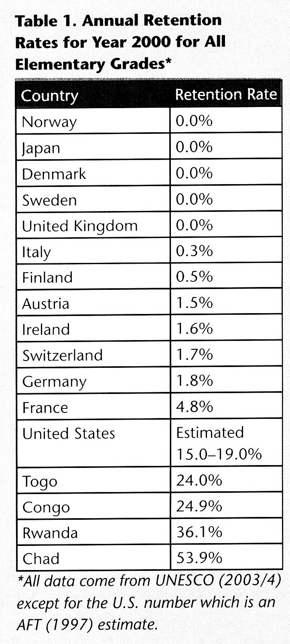
http://proquest.umi.com.ezproxy.fgcu.edu/pqdlink?vinst=PROD&fmt=4&filenumber=2&ver=1&vname=PQD&RQT=309&did=955429371&exp=02-24-2011&scaling=HALF&vtype=PQD&rqt=309 Retrieved 01/26/06 (D2)

