Speed of Sound

Objective: To measure the speed of sound in air at room temperature using resonance in air columns.

Equipment: Resonance column apparatus, a set of tuning forks.

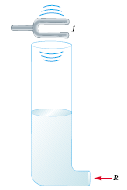

Reference: R.D. Knight, Physics for Scientists and Engineers, Ch.21 Superposition

Theory:

You will determine the speed of sound in air by measuring the wavelength of a standing wave for a sound of known frequency. A standing wave is what you get when two or more traveling waves combine in such a way that there are some places where there is no motion at all, and those places are called nodes. For any wave with wavelength λ (in m) and frequency f (in vibrations/s, or 1/s, or Hz), the speed of the wave (v, in m/s) is:

λf = v

A sound wave is a traveling variation in air pressure, the air itself is not transported from one side of the room to the other. The speed it travels depends on the pressure, humidity and temperature of the air. High humidity, high temperature and high pressure all lead to a higher speed v. In a tube, which is closed at one end and open at the other, you can get a standing sound wave set up in the tube with a displacement node at the closed end, and a displacement antinode at the open end. See pictures below. What that means is, the open end will be a place where the air vibrates most vigorously (a displacement antinode) and at the closed end there will be a minimum amount of vibration (a displacement node).

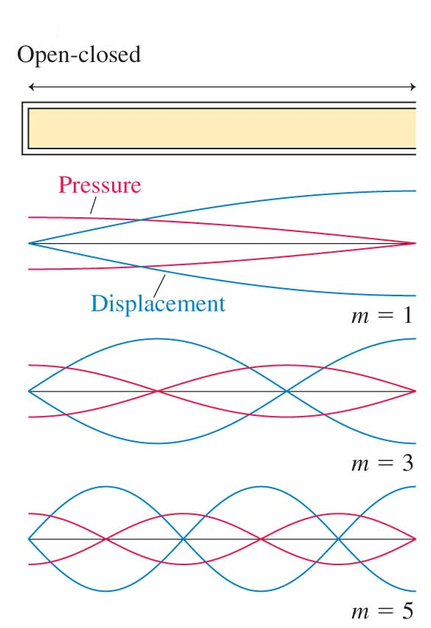 | 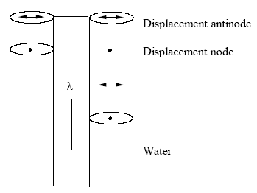  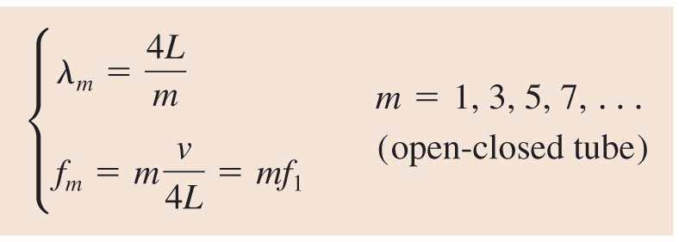

For the first standing wave shown, notice that the wavelength is 4 times the length of the portion of the tube containing air, so we've “fit" 1/4 of a wavelength in the tube. If we now make the air column 3 times longer, we'll be able to “fit" ¾ of a wavelength in the tube. In general, we can capture 1/4; 3/4; 5/4; … of the wavelength in the tube, by adjusting the level of water to just the right length. It all comes from insisting that there be a displacement antinode at the open end and a displacement node at the closed end.
Next, you should know about resonance. For example: play a note A (440
vibrations/s) next to a string whose length is such that one of its possible standing waves has this same frequency. Then the string will vibrate at 440 Hz, even if you don't pluck it. This is called resonance. So, say you hold a tuning fork above a tube with one end open and the other end closed. If you adjust the length of the air column in the tube, and you find the shortest length at which the tube will resonate (you will be able to hear it), you will know that the length of the column is 1/4 of the wavelength of the sound wave. Now keep making the column longer, and the next time you hear resonance, your tube will have reached 3/4 of the wavelength. The next resonance will be at a length of 5/4 the wavelength, and so on. If the frequency is stamped on the tuning fork, then you will have frequency and wavelength, and you can multiply them together and find the speed of sound in air.
A general expression for the speed of sound in a gas, from which we can derive the expression:

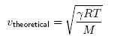

where γ= 1.4, R = 8314 J/(kmol·K), T = temperature of the room during the experiment in K, and M = 28:8 kg/kmol. Thus, by measuring the temperature of the room in _C and adding 273 to convert it to K, you can make an independent estimate of what the speed of sound should be.

Activity:

As explained above, for a tone of wavelength λ, there can be a standing wave
in an air-filled cavity of length L closed at one end if:

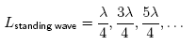

In reality it is not quite true. The top antinode is located slightly above (x cm) the tube, so you have

L_{n} + x = n·λ/4

Using a glass tube filled to a variable height with water, you will vary L until you find the place of resonance for various tuning forks of known frequencies, and thus find λ. The easiest way to do this is to find the distance between any two neighboring resonance points (which will be 1/2 of a wavelength), and multiply that by 2 to get λ. In this case you will not need to know the correction x. Indeed,

(L2 + x) – (L1 +x) = distance between any two neighboring resonance = 3λ/4 - λ/4 = λ/2

The speed of sound can then be calculated by multiplying the wavelength λ by the frequency f stamped on the tuning fork. Do this three times, using a different tuning fork and/or a different pair of neighboring resonances each time. The highest and lowest values give you range - your experiment predicts v to be within that range of values.
Now measure the room temperature T and convert it to K, and calculate the theoretical speed of sound vtheoretical using equation above.
Check to see whether the value you obtained for vtheoretical falls within the
range obtained for vexperimental. In addition, you should compare your range of values for vexperimental to that of at least one other lab group. You are both measuring the same thing at approximately the same time in approximately the same place, so your results should agree; see if they do.
Take care with the following:
- Take your time and try to find the points of resonance as precisely as possible; it's not easy to find the exact place. Once you have found your first resonance point, try holding the tuning fork in different orientations to find which one gives the best response, then find the resonance point again and start taking data.
- Don't knock the tuning forks against a hard surface - it dents them and this might change their frequency slightly. Hit them against piece of rubber.
- The tubes are marked in cm. Convert your measurements to m, before doing any calculations, so that your final answer is in m/s.

What to Include in the Lab Report:

- Table with data:

Number | f (Hz) | L₁ (m) | L₂ (m) | (L₂ – L₁) (m)
1
2
3
4

- In this experiment f and (L₂ – L₁₎ are your variables. Use equation v = 2f(L₂ – L₁) in the form y = mx + b. Identify y, x and b and write them down. Draw an appropriate graph and measure its slope. Use the slope to obtain a value for the velocity of sound in air at room temperature.
- Speed of sound in air is given by the equation $v=\sqrt{\frac{\text{RT}}{M}}$ where r is the gas constant, M is the molar mass of air and T is the Kelvin temperature. Use your measured value of speed of sound and the room temperature to obtain a value for the speed of sound in air at (a) 0ºC, (b) at 100ºC.
- Using the relation λ = v/f and using equation L₁ + x = λ/4, calculate 4 different values of x, the end correction using the measured value of v and the four frequencies of the tuning forks. Also obtain 4 values of x using equation
- L₂ + x = 3λ/4. Obtain an average value for x.
- Use a vernier caliper to measure the inner diameter (D) of the tube. Calculate the end correction x as x = 0.4 D. Obtain a percentage difference between this value of x and the one you obtained in 2 above.
- Suppose the laboratory temperature was 10ºC higher than the temperature at which you performed the experiment. Explain what effect this would have on your experimental result.
- A rough relation between speed of sound in air and temperature can be written as v = v_{o} + 0.6t where v_{o} is the speed at 0ºC and t is measured in ºC. Use your experimental value to obtain the value of v_{o}.
- What are the first three resonant frequencies of a 20 cm tube closed at one end. Use the speed of sound you obtained in this experiment to answer this question.

