RC Circuits

Equipment:
RC circuit board equipped with ~15 kΩ resistor and ~1000 μF capacitor
Pasco device (connected to charger) with voltage cable
Digital multimeter
Connecting clips and wires
AA-sized battery

Goal:
To determine the time constant of an RC circuit and to use this time constant to more precisely verify the capacitance of the circuit.

Introduction/Theory:
Consider a simple RC circuit consisting of one resistor and one capacitor. The capacitor will be charged by connecting the two elements in series with a battery.

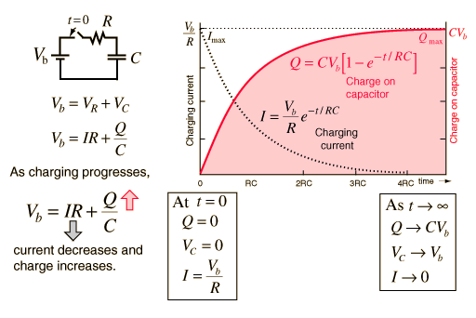
see http://hyperphysics.phy-astr.gsu.edu/hbase/electric/capchg.html

The capacitor will be discharged by removing the battery from the circuit.

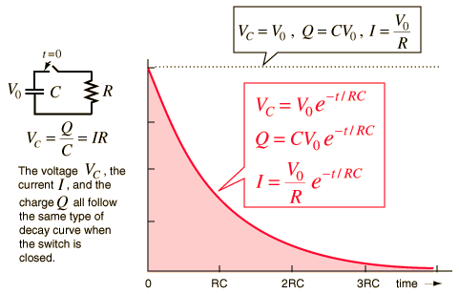
see http://hyperphysics.phy-astr.gsu.edu/hbase/electric/capdis.html#c2

Define the quantity τ as the time constant of the circuit (metric units of seconds).
τ = RC

Beginning when the capacitor discharges, after a time interval equal to the time constant has passed, the voltage across the capacitor will be equal to 38% of its maximum value.

The time constant can also be determined by measuring the time it takes for the voltage across the capacitor to drop to 50% of its maximum value. This time interval will be equal to approximately 69% of the time constant.

Procedure:
- Use the digital multimeter as an ohmmeter to measure and record the resistor’s resistance R.
- Use the circuit board’s small connecting wire to connect the resistor and capacitor in series. Also insert the AA battery in its place on the circuit board and select “battery.”
- Switch the circuit to “discharge” and leave it open for a couple of minutes.
- Connect the voltage cable to the circuit board so that it will measure voltage across the capacitor (there are handy pegs on the circuit board). The red voltage cable should be attached to the positive end of the capacitor, and black attached to negative.
- Insert the other end of the voltage cable in the Pasco device and turn on the Pasco device if it isn’t already on.
- Select “Graph” from the Pasco home screen (if needed). You should see a plot of Voltage in Volts vs. time in seconds. If not, use the cursor keys to highlight the vertical axis and select “Voltage.”
- Begin recording on the Pasco device.
- Switch the RC circuit board to “charge” to begin charging the capacitor.
- Monitor the capacitor’s increasing voltage on the screen. When the voltage has leveled out, switch the circuit board to “discharge” to begin discharging the capacitor.
- Continue recording as the capacitor’s voltage decreases. Stop recording once the voltage has leveled out at 0 volts.
- Determine Vmax from your graph. Calculate and record 0.5*V_{max} and 0.38*V_{max}.
- From your graph, determine and record the time of maximum voltage immediately before the capacitor began discharging “t_{max},” the time corresponding to discharging voltage = 0.38*V_{max} “t₃₈,” and the time corresponding to discharging voltage = 0.50*V_{max} “t₅₀.”
- Sketch your graph of voltage vs. time for the charging and discharging capacitor. On your graph, label V_{max}, t_{max}, t₃₈ and t₅₀. (this will be part of your lab report)
- Disconnect the voltage cable from the capacitor and reattach the cable so that it will now measure the voltage across the resistor.
- Repeat steps 7 – 14 for the resistor. Note that the resistor voltage values (including Vmax) will actually be negative as the capacitor discharges.
- Complete calculations to determine four estimates of the time constant “τ” and find their average value.
- Use the average τ and your measured resistance R to calculate the capacitance C in μF.

Measured values:

R = _______________

Capacitor data:

V_{max} = ______________ t_{max} = __________________

0.38*V_{max} = ______________ t₃₈ = ________________

0.50*V_{max} = _______________ t₅₀ = ________________

Resistor data:

V_{max} = ______________ t_{max} = __________________

0.38*V_{max} = ______________ t₃₈ = ________________

0.50*V_{max} = _______________ t₅₀ = ________________

Calculated values:
Capacitor data:

τ₁ = t₃₈ – t_{max} = ______________

0.69*τ₂ = t₅₀ – t_{max} = _______________ τ₂ = ___________________

Resistor data:

τ₃ = t₃₈ – t_{max} = ______________

0.69*τ₄ = t₅₀ – t_{max} = _______________ τ₄ = ___________________

Average value τ_{avg} = ____________________

Capacitance C = τ_{avg} / R = __________________

Follow-up material to include in your Analysis:

Qualitatively discuss the errors in determining τ and C.

Qualitatively discuss the similarities and differences between your two sketched plots. Draw upon the expected appearance of each graph and the expected differences between the two graphs as discussed in class and in your text.

