Student Name: __________________
Date: __________________

Student Laboratory Data Sheet
for
ACUMEN Spectra Lab

Section 1

1) Identify the following Spectra types:
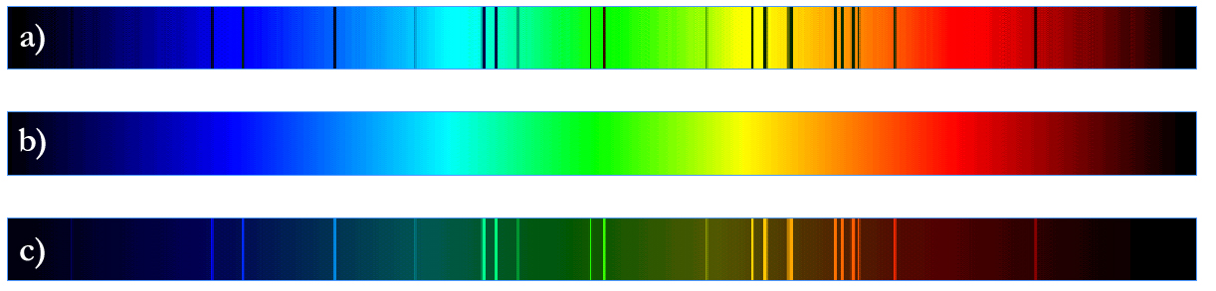

a) b) c)

2) Two types of spectroscopes are ______________ and a __________ ___________

3) When a continuous spectrum passes through a cool, low density gas, what type of spectra is produced?

____________________

4) What type of spectrum contains dark lines superimposed over a continuous spectrum?

______________________

5) What is the purpose of a spectrometer? __________________________________

_____________________________________________________________________

Section 2

6) Which element produces more emission lines in an emission spectra, Hydrogen or Iron? ___________

7) What is the wavelength of the strongest emission line in the helium spectra? _______

8) What elements are present in the spectra of the unknowns?

Unknown #1 | Unknown #2 | Unknown #3

Section 3

9) Using the hydrogen energy diagram, how much energy is required to excite an electron from ground state to n=3?

______________

10) What photon wavelength is required to excite an electron from n=3 to n=4?

_______________

11) What is the first transition in the Balmer series commonly known as?

______________________

12) Will a hydrogen atom with an excited electron at n=2 absorb a photon having a wavelength of 40515 Angstroms?

_______

- Assume a hydrogen atom has an electron excited at n=3. What are the possible photon energy levels released by the electron as it goes to ground state?

________________________

Section 4

14) Light from a star that is traveling towards you will appear _________ in color due to the _____________________ .

15) List 5 things which can affect spectra

1) _________________________ 2) __________________________

3) _________________________ 4) __________________________

5) _________________________

Section 5 & 6
16) Briefly explain how spectra can be used to…

a) …determine the chemical composition of a star.

b) …determine how fast a star is moving.

c) …determine the temperature of a star.

d) …determine the magnetic field of a star.

e) …determine how fast a star is rotating.

