Name:

Lab Partner:

The Quest for Object X
Student Manual
A Manual to Accompany Software for the Introductory Astronomy Lab Exercise
Edited by Lucy Kulbago, John Carroll University
11/24/08

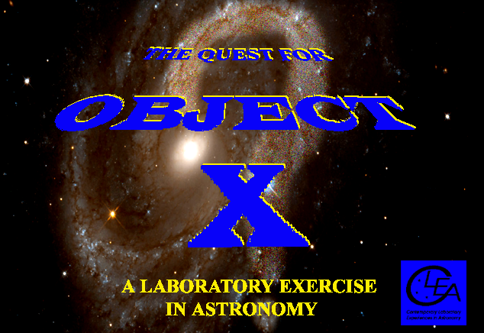

Department of Physics
Gettysburg College
Gettysburg, PA 17325

Telephone: (717) 337-6019
Email: clea@gettysburg.edu



Contents

Goals 3
Objectives 3
Useful terminology 3
Introduction 4
Identifying Astronomical Objects 5
Criteria for Distinguishing Astronomical Objects 7
Coordinates for Object X 7
VIREO: The CLEA VIRtual Educational Observatory 8
- Optical Telescope Controls 9
- Radio Telescope Controls 11
- Additional Analysis Tools 13
Reporting your results 16
Useful references 18
Appendices 22
- A: Astronomical Constants and Conversion Factors 18
- B: Useful Formulas 19
- C: Distinguishing Features of Main Sequence Spectra 20
- D: Absolute Magnitude and B-V Versus Spectral Type 21

Goals

Given the celestial coordinates of a celestial object, you should be able to use observations with a variety of astronomical instruments at a variety of wavelengths and times to determine what kind of an object it is . You should also be able to use observations to determine some of its physical properties such as temperature, distance, velocity, etc. (depending on the type of object).
Ultimately, you should get a better appreciation of the distinction between observations—which produce data --- and interpretations, which are conclusions about the characteristics of an object drawn from the data.

Objectives

If you learn to...
- Operate CLEA’s simulated optical and radio telescopes.
- Locate objects using celestial coordinates.
- Take spectra, images, and photometric measurements.
- Recognize the identifying characteristics of stars, galaxies, asteroids, pulsars, and other objects in the heavens.
- Understand which types of measurements yield useful information about celestial objects.
- Calculate the properties of celestial objects from various types of measurements.

You should be able to…
- Identify what kind of an object you have been given by your instructor.
- Make additional measurements that will enable you to identify at least some of these properties: size, temperature, distance, velocity, period of rotation, age, composition.
- Developing an understanding of what astronomers do when they conduct research.
- Appreciate some of the difficulties and limitations in making astronomical discoveries.

Useful terminology you should review in your notes and textbook

Absolute Magnitude | Absorption line | Apparent magnitude | Asteroid | Astronomical Unit
Brightness | CCD Camera | Declination | Distance modulus | Doppler shift
Emission line | Frequency | Galaxy | HR Diagram | Hubble relation
Infrared | Light Year | Parsec | Photometer | Pulsar
Radial velocity | Radio Telescope | Red shift | Right Ascension | Spectral type
Spectrometer | Spectrum | Star | Transverse velocity | Universal time
Wavelength

THE QUEST FOR OBJECT X

Introduction

What does it mean to say that an astronomer has “discovered” something? In many fields of science, discovery implies finding something that is hidden out of sight, such as digging up a fossil hidden under layers of clay, discovering the chemical structure of an enzyme, or traveling to the heart of the rainforest to photograph a previously unknown species of songbird.
But how does this apply to astronomy? The skies are in full view, with the exception of objects that lie below the horizon. If you are willing to wait for the earth to turn and if you are able to travel to a different hemisphere, you can see the entire sky. If you take a longer exposure or use a larger telescope, you can see fainter and fainter things. Nothing can be really hidden.
There are so many things in the sky, however, that what may be in full view may not be easy to distinguish. The main task of astronomical discovery, in short, is to recognize a few objects of interest among the billions and billions of points of light we detect up there. It’s like the puzzles in the “Where’s Waldo?” books, which ask the reader tries to find one person in a crowd of thousands—you can stare straight at the object you’re looking for, yet fail to find what’s right before your eyes.
To appreciate the difficulty of discovering something of interest among the multitude of lights in the sky, consider the following: On a dark moonless night, a good observer can see about 3000 stars at any given time with the naked eye. The telescopes and electronic cameras used by astronomers today increase this number immensely. If you count stars as down to one ten thousandth the brightness of those just barely visible to the naked eye, the number is about 20 million, and the number rises quickly into the billions as one goes still fainter. Long exposures with the best telescopes can see things a million times fainter still, and no one has attempted to make a complete count of the billions and billions of objects visible at that level.
Most of the things in the sky look like dots or smudges of light. Even through the biggest telescopes only a few objects, like the large planets, a few galaxies and nebulae, show distinguishing details. It takes careful observation—with spectrometers, photometers, imaging cameras at a wide range of wavelengths to distinguish one smudge from another. Just as an analytical chemist works with white powders, trying to figure out what they’re made of, so an astronomer takes data on little dots and smudges of light in order to “discover” their true nature.
This is an exercise in astronomical discovery. It’s simple in concept: you will be given the celestial coordinates (Right ascension and Declination) of a mystery object, the “unknown”, Object X. Using the techniques of observational astronomy, you will identify the object and find out all you can about its physical characteristics (e.g. the distance, temperature, and luminosity of a star in the Milky Way, or the speed and distance of a remote galaxy.)

IDENTIFYING ASTRONOMICAL OBJECTS

As an astronomer you are presented with an unknown object. All you know are its celestial coordinates, Right Ascension and Declination, which tell you where in the sky to point your telescope. How do you figure out what the object is?
To understand the basic method, consider a more familiar situation: You are a chemist, and someone gives you a white powder. What do you do to find out what it is made of? The general technique is to run the powder through a series of standard procedures to see what results it produces. A chemist may place the powder in a mass spectrometer, which will produce a graph indicating the presence of various chemical elements. A teaspoon of the powder might be weighed on a sensitive balance to see how dense it is. Or the chemist may put the powder in a test tube and add another reactive substance to see what happens---a solution might change colors, or a precipitate might form.
Astronomers analyze the light from an unknown object in similar fashion—they run it through a series of tests. The first thing an astronomer might do is to point a telescope at the unknown object and take a picture of it. That might immediately settle what it is---if the object looks like a large extended spiral of light, then it’s a relatively nearby spiral galaxy. But suppose it looks like a point source---a little dot of light---then the decision is not as clear. It could bean asteroid in our own solar system; it could be a star a few light years away; it could be a distant galaxy hundreds of millions of light years distant (which is too far away for its shape to be visible); it could even be a quasar (a small source of intense radiation, powered by a super-massive black hole), billions of light years away
To settle the question, you would perform an additional test. You could attach a spectroscope to your telescope and take a spectrum of the light from the unknown object. Suppose the spectrum looked like this (figure 1) , with only a few broad spectral lines visible, and the distinctive pattern of two close lines (from ionized Calcium atoms) at the short wavelength end of the spectrum:

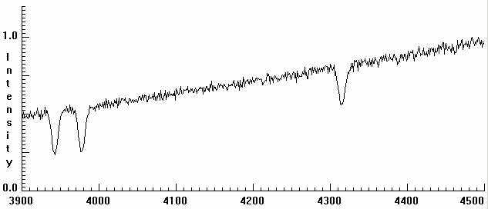
Figure 1: Spectrum of a Galaxy

This is a typical galaxy spectrum, as distinct from the spectrum of a star, say, which might look like the spectrum below (figure 2) , which has a different and distinctive pattern of spectral lines.
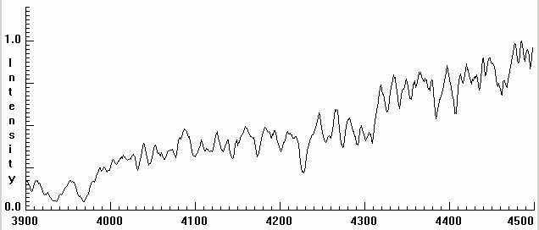
Figure 2:
Spectrum of a Star

While galaxy spectra look pretty much the same (because they are the average of millions of stars of different kinds), the spectra of stars differ from one spectral type to the other. Here’s another star spectrum (figure 3) of a different spectral type.
Figure 3:
A star spectrum of a different spectral type from that in figure 2
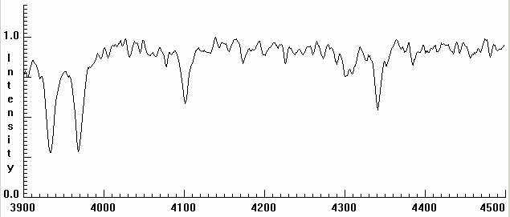

Since our unknown object in this case has the spectrum of a galaxy, we identify it as such, and can then proceed to determine some of its properties from the spectrum, notably its redshift, its speed of recession from us, and its distance.
If the spectrum of the object had been that of a star, we would have been able to determine its spectral type and its absolute magnitude from its spectrum. We might have gone on to determine the apparent magnitude of the star using a photometer. Then from the absolute and apparent magnitudes we could have determined the distance of the star.
Sometimes it’s just that simple. If we classified the spectrum and found that it was a B5 main-sequence star, we could rest assured that the object was indeed a star, and we could go ahead and determine its properties from tables of the properties of various types of stars.
Sometimes it’s not that simple, however, and additional observations are necessary to reach a firm identification. Suppose the unknown spectrum was that of a G2 main-sequence star, which happens to be the spectral type of our own sun. Though there are plenty of G2 stars in the sky, it’s also possible that the object might not be a star at all but an asteroid in our solar system, reflecting the light of our sun.

Criteria for Identifying Astronomical Objects
TYPE OF OBJECT | OBSERVATIONAL CHARACTERISTICS | PHYSICAL QUANTITIES DERIVABLE FROM OBSERVATIONS
Star | - Optical:  Point Source  Absorption Spectrum  Matches Stellar Spectral atlas type.  Radio:  Not Detectable | - Spectral Type  Temperature  Luminosity  Distance  Galactic Coordinates  Age (if in cluster)
Normal Galaxy | Optical:  Extended Source. But may appear as Point Source if sufficiently distant  Absorption Spectrum, late type composite. H, K lines and G band prominent.  Notable red-shift.  Radio:  Weak or non-detectable. | - Radial velocity  Distance (assuming H₀) or using an independent standard candle such as Cepheids or Type Ia Supernova.
Pulsar | Optical:  Not detectable except for a very few of the youngest (e.g. Crab, Vela)  Radio:  Short duration, periodic bursts  Period ~10⁻³ to 10 sec. | - Rotation period  Distance (assuming interstellar electron density).  Age

Table 1

THE COORDINATES OF OBJECT X

RIGHT ASCENSION DECLINATION
Object Number | H | M | S | ˚ | ´ | "
1 | 3 | 32 | 59.35 | 54 | 34 | 43.2
7 | 12 | 19 | 30.68 | 14 | 52 | 38.1
12 | 12 | 44 | 33.65 | 32 | 20 | 16.7

Table 2
THE CLEA VIRTUAL EDUCATIONAL OBSERVATORY (VIREO)

The coordinates of your unknown object are given in Table 2. You will now want to run the VIRtual Educational Observatory (VIREO), available on your laboratory computer. This software gives you access to a variety of telescopes and measuring instruments which you can use to examine and analyze the radiation from Object X. You can then think over what you want to use first, and begin to develop a strategy for identifying the unknown.
Click on File, Login, then File, Run. Enter an object number and Click OK. Go to Telescopes and choose either an optical telescope or a radio telescope. If you choose an optical telescope, open the dome. For both the Optical and Radio Telescopes, turn on the telescope controls for the telescope you have selected by clicking on the button on the bottom right, as shown in Figure 4.
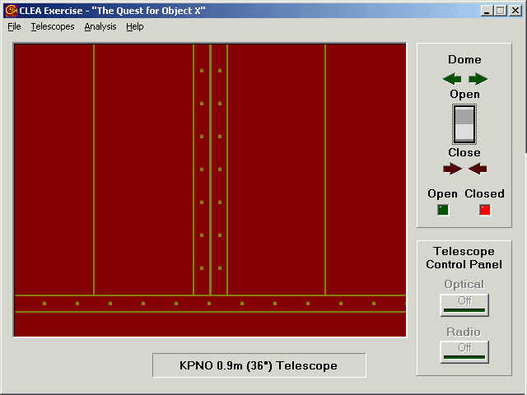

Figure 4: The Main Observatory Window

Optical Telescope Control

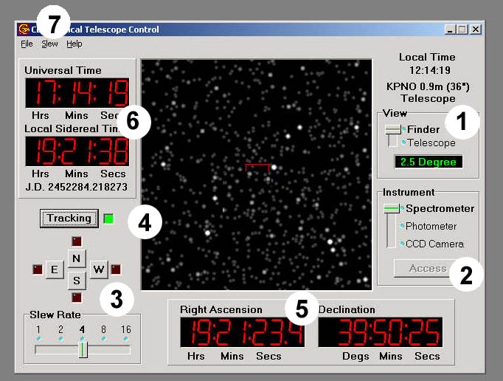
This is the optical telescope control window.

Figure 5: The telescope control window

In addition to the TV screen in the center that shows the view through the telescope, there are:
- Controls to zoom in from a wide field Finder view to a magnified narrow-field Telescope view.
- Controls to select instruments to attach to the telescope.
- Controls to move Slew the telescope.
- A control to turn on the telescope so that it tracks the stars. (NOTE: tracking must be turned on in order to use the other features of the telescope. If the tracking is off, the stars will appear to move through the TV viewer as the earth turns).
- Displays of the coordinates in the sky that the telescope is pointed at.
- Displays of time.
- A pull down menu in which you can enter the exact coordinates of stars you want the telescope to move to.

You’ll want to turn on the tracking by pushing the Tracking button (the green tracking light goes on and the stars stop drifting westward on the TV). You will want to slew the telescope to the coordinates of your unknown object. You will want to get a magnified view of the object by switching to the narrow field Telescope view. You can then select the instrument you want to use to analyze the light of the object.

Instruments for the Optical Telescopes:

The Aperture Photometer: The photometer measures the brightness of light coming in through a small circular hole positioned in the image plane of the telescope. Filters can be placed between the hole and the photomultiplier tube that counts the photons of light as they come in. The telescope can be pointed at a star and all the light from the star, which goes through the photometer hole will be counted---as well as some background light from the night sky as well (caused by reflected city lights, emission of molecules in the atmosphere, etc. ). The photometer should first be pointed at some blank sky to measure the background level---it will not calculate stellar magnitudes if you don’t do this first. Once it has recorded the sky background, you can then point it to stars you want to measure. (See CLEA’s Phototelectric Photometry of the Pleiades exercise for details).

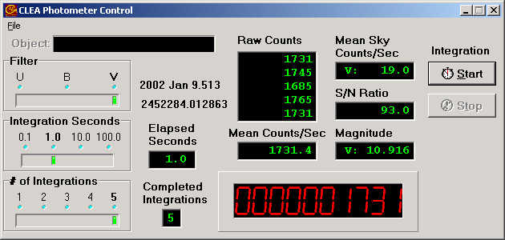

Figure 6: The Photometer Window

The Photon-Counting Spectrometer: The photon-counting spectrometer takes light that falls on a small slit in the image plane of the telescope and uses a grating to spread the light out into a spectrum, a graph of intensity versus wavelength. The longer you expose the spectrum, the clear and more detailed it the graph will be. The intensity and wavelengths of points on the graph can be measured by pointing the mouse at the graph. The spectrum can also be saved for later analysis and measurement. For instance there is a classification tool that can be used to compare an unknown spectrum to a series of known comparison spectra.
Since photons of light come in at random times, you also need to make sure to collect about 10000 photons to make sure you have enough for a good statistical estimate of the brightness of the star. You can increase the exposure (“integration”) time, or the number of trials the photometer takes, to reach this number. For very faint stars, you may not be able to get 10000 photons in a reasonable time, but your results will therefore not be as reliable.

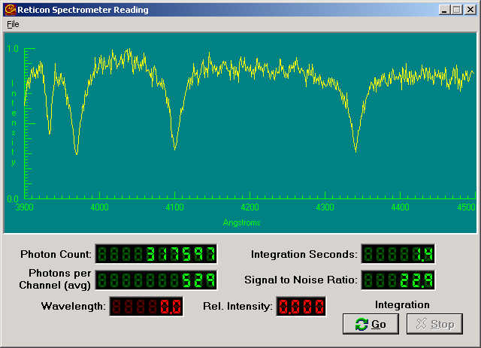

Figure 7: The Spectrometer window.

The CCD Camera: You will NOT need to use the camera for this exercise.

Radio Telescope Control

The Radio Telescope: Many objects in the heavens emit more at radio wavelengths than in visible light, and can best be detected with a radio telescope. You can access the CLEA radio telescope from the main window. The radio telescope control window (Figure 9) looks very much like the optical telescope window. However it controls a large radio dish antenna which can collect radio waves and send them to a radio receiver. Like the optical telescope, the antenna can track objects as they move across the sky. It can also be left stationary, picking up objects as the rotation of the earth moves the sky in front of it. (Astronomers call this “transit” mode of operation).
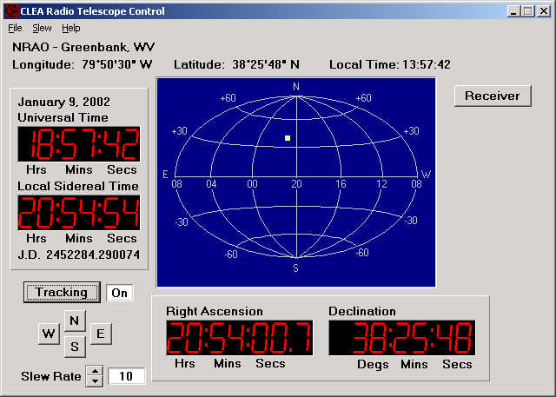
Figure 8: The Radio Telescope Control Window

The radio telescope window controls the telescope motion and has time and coordinate displays like the optical telescope. The only difference is that, since it cannot actually see stars, there is no TV in the center to display starlight. Instead a map indicates where in the sky the telescope is pointed. There is a button in the upper right that turns on the instruments attached to the dish once the telescope is pointed to an object; these instruments are called radio receivers.

Instruments for the Radio Telescope:
Tunable Radio Receivers. (3 available) : Radio radiation collected by the dish antenna is fed to a radio receiver which can be actuated by the Receiver button on the radio telescope control window. The receiver control window that appears is shown in Figure 9.

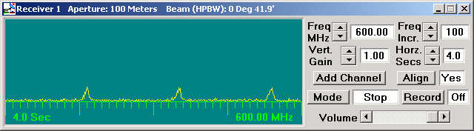

Figure 9: The Tunable Radio Receiver

The radio receiver takes an incoming signal and graphs it versus time on the screen. The controls on the radio receiver are like those on an ordinary radio. You can tune the receiver between 400 and 1400 MHz using the buttons at the top. The vertical gain control adjusts how high signals appear on the screen. The horizontal seconds control adjusts the speed of the graph across the screen---it can be adjusted to spread out quickly varying signals so they are more visible. To turn on the graph, the mode switch is pressed. To stop the graphing, press it again, and the graph will stop when it has finished the current sweep across the screen. Data can be recorded and stored on files for later playback. The sound of the incoming signals can even be heard, if your computer has a sound card, by adjusting the volume control.
By pushing the “add channel” button, additional receivers can be displayed, up to three in all. These can be tuned to different frequencies as desired. Comparing signals at different frequencies is most useful in determining the distance of pulsars (see the CLEA lab Radio Astronomy of Pulsars for an example).

Additional Analysis Tools:

Software tools for analyzing the data collected with the various telescopes are accessed through the Tools menu on the main observatory page.

Spectrum Classification Tool
Spectra collected by the optical spectrometer are saved as files with an extension .CSP. The spectra can be displayed in the spectrum classification tool window. This window allows you to magnify the spectra, measure intensity and wavelength at any point, and measure the amount of absorption (called the “equivalent width”) of spectral lines. To aid in spectral classification, it is also possible to display spectra of standard stars of various spectral types in windows directly adjacent to the spectrum of the unknown.

Figure 10 shows the appearance of the spectrum classification tool. For details, see CLEA Lab Classification of Stellar Spectra. To access the Atlas of Main Sequence Spectra Go to File, Atlas of Standard Spectra.
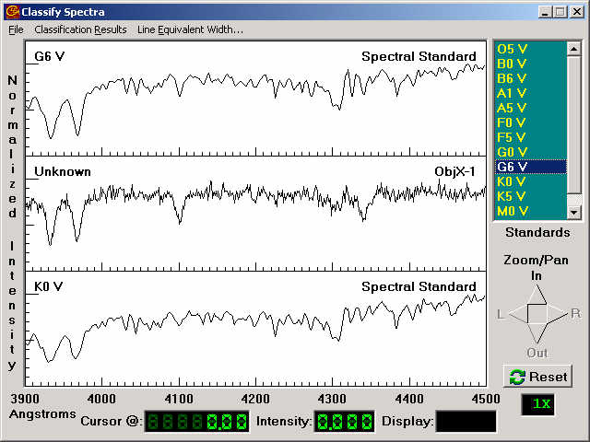

Figure 10: The Spectral Classification Tool

Spectrum Measuring Tool
Spectra collected with the optical spectrometer are saved as files with an extension .CSP. The spectra can be displayed in the spectrum measuring tool window, shown in Figure 11. This tool can help identify the redshift of the K and H absorption lines of calcium. To access the comparison spectrum for the absorption lines, click on Comparison Spectrum and Select Absorption lines in normal galaxies. Slide the red lines to match the calcium absorption lines, and then measure their wavelengths and record this in the data table.
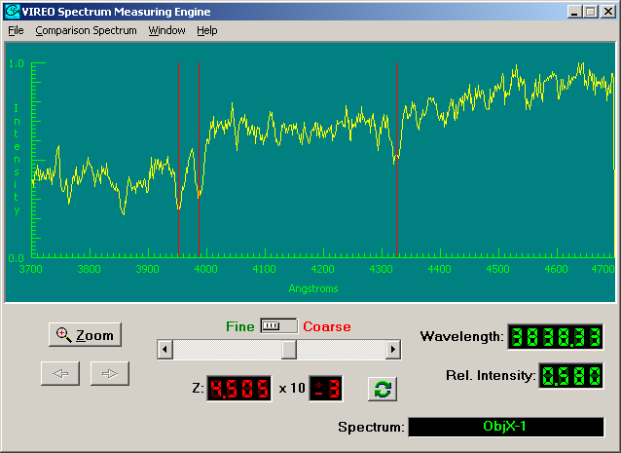

Figure 11: Spectrum Measuring Tool

Radio Pulsar Analysis Tool
Signals recorded by the radio receivers are saved as files with extension .PLR. These radio data files, which represent radio intensity versus time, can be examined with the radio analysis tool, figure 13. The radio analysis tool has features for magnifying the scale of the display, for measuring time and intensity, and for comparing signals from up to three receivers. Cursors can be used to mark important points in both the horizontal and vertical axes by clicking the mouse buttons. For details see the CLEA Lab Radio Astronomy of Pulsars.
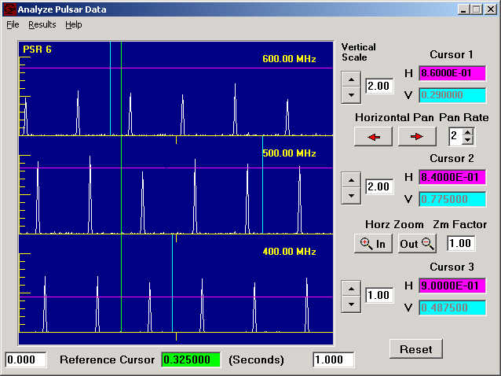

Figure 12: The Pulsar Analysis Tool

REPORTING YOUR RESULTS

You have been assigned 3 objects to identify. They will be either a Main Sequence Star, a Regular Galaxy, or a Pulsar. Fill in the appropriate chart for each object. Fill in the object name or number on the line. Use your previous lab manuals or the appendices of this lab to find appropriate procedures and formulas.

- Main Sequence Star: _______________________

Spectral Type | Absolute Magnitude M | Apparent Magnitude m | Distance in parsecs

- Use the photometer’s V filter to find apparent magnitude. Don’t forget to get a background sky reading away from the object.
- Photons can be collected using the spectrometer and the data can be analyzed by using the tools found under the Tools link on the main window menu bar.

- Regular Galaxy: _____________________

Abs Mag M | App Mag m | Dist (pc) | Dist (Mpc) | λ_{K measured} | λ_{H measured} | Δλ_{K} | Δλ_{H} | Velocity K | Velocity H | Velocity Avg
-22

- Use the photometer’s V filter to find apparent magnitude. Don’t forget to get a background sky reading away from the object.
- Photons can be collected using the spectrometer and the data can be analyzed by using the tools found under the Tools link on the main window menu bar.
- Use a value of 70 km/sec/Mpc for the Hubble Parameter when calculating the recessional velocity.

- Pulsar: _________________________

Frequency | Time of First Pulse | Time of Last Pulse | Number of Periods | Period of Pulsar

f₁ ____________ f2 ____________ f3 ____________

T_{f1} ___________ T_{f2} ___________ T_{f3} ___________

f_{A} | f_{B} | T_{B} – T_{A} | (1/f_{B})² – (1/f_{A})² | D (pc)

- Data can be collected and saved for analysis using the Tools link on the main window menu bar.

USEFUL REFERENCES

This exercise presumes familiarity with the several of the other CLEA Exercises: Manuals and software for these exercises are available on the CLEA webpage: http://www.gettysburg.edu/academics/physics/clea/CLEAhome.html
- Photoelectric Photometry of the Pleiades
- The Classification of Stellar Spectra
- The Hubble Red-Shift Distance Relation
- Radio Astronomy of Pulsars
- Astrometry of Asteroids

Appendix A: USEFUL ASTRONOMICAL CONSTANTS AND INFORMATION

Time
Number of seconds in an hour | 3600
Number of seconds in a year | 3.1 x 10⁷
Density and Mass
Density of water | 1 kg/m³ or 1 g/cm³
Mass of the sun (One Solar Mass) | 1.99 x 10³⁰ kg
Mass of the earth | 5.98 x 10²⁴ kg
Length
Ångstrom unit | 10⁻¹⁰ m = 10⁻⁸ cm = 10 nanometers
kilometer | 10⁵ cm = 10³ m
Astronomical Unit (AU) | 1.5 x 10⁸ km
light year | 9.5 x 10¹² km = 9.5 x 10¹⁷ cm
parsec | 3.09 x 10¹³ km = 206265 AU = 3.26 ly
Radius of the sun | 7 x 10⁵ km
Velocity
Velocity of light | c = 3 x 10⁵ km/sec = 3 x 10¹⁰ cm/sec
Angular Measure
Degree (˚) | 60 arcminutes (‘) = 3600 arcseconds (“)
1 Hour of Right Ascension | 15 degrees
Miscellaneous Astronomical Constants
Hubble Constant | 65 ± 5 km/sec/mpc
Mean angular size of the moon | ~ 1800 arcseconds

Appendix B: USEFUL FORMULAS

Relation between distance, absolute magnitude and apparent magnitude

D = 10 ^{(m – M + 5) / 5} | Where D is the distance in Parsecs, m is the apparent magnitude, and M is the absolute Magnitude

Relation between time of arrival of two pulses at two different frequencies from the same pulsar, and the distance of the pulsar.

D = T₂ –T₁  124.5 { (1/f₂)² - (1/f₁)² } | Where T₁ is the arrival time of the pulse at frequency f₁, and T₂ is the arrival time of the pulse at frequency f₂.

The Hubble Redshift-Distance Relation

V= HD | Where V is the velocity of the galaxy in km/sec, D is the distance of the Galaxy in megaparsecs (mpc), and H is the Hubble constant in km/sec/mpc. Use the value 65 km/sec/mpc for the Hubble constant.
Appendix C: DISTINGUISHING FEATURES OF MAIN SEQUENCE SPECTRA

Spectral Type | Surface Temperature | Distinguishing Features  (absorption lines unless noted otherwise)
O | 28000-48000 | Ionized atoms especially singly ionized helium, He II
B | 10000-28000 | Neutral helium, He I, and some neutral hydrogen, HI, in cooler types
A | 8000-10000 | Strongest HI Balmer lines at A0. Ionized calcium, CaII increasing at cooler types. Some other ionized metals
F | 6000-8000 | CaII stronger; HI weaker; ionized metal lines appearing, including iron, Fe
G | 4900-6000 | CaII very strong; Fe and other metals strong with neutral metal lines appearing, H weakening. Our Sun is G2
K | 3500-4900 | Neutral metal lines strong; CH and CN molecular gands beginning to develop in the cooler types.
M | 2500-3500 | Very many lines; TiO and other molecular bands prominent. Neutral Calcium, CaI, prominent. S stars show Zr) and N stars show C₂ lines as well.
L | 1300-2500 | Neutral potassium, K, cesium, Cs, Rubidium, Rb, and hydrides of metals (molecules with one H atom). Strong infrared continuum.
T | Below 1300 | Some water (H₂O) and strong KI; Strong infrared continuum
WR (Wolf-Rayet) | 40000+ | Broad Emission of He II; WC stars show doubly and triply ionized Carbon: CII and CIV; WN stars show NII prominently
Appendix D: ABSOLUTE MAGNITUDE AND B-V VERSUS SPECTRAL TYPE

(From C.W. Allen, Astrophysical Quantities, The Athlone Press, London, 1973)
Giants, Luminosity Class IIISpectral TypeAbsolute Magnitude, MG0+1.1G5+0.7K0+0.5K5-0.2M0-0.4M5-0.8
Main Sequence Stars, Luminosity Class V
Spectral Type | Absolute Magnitude, M | Color Index, B-V
O5 | -5.8 | -0.35
B0 | -4.1 | -0.31
B5 | -1.1 | -0.16
A0 | +0.7 | 0.0
A5 | +2.0 | 0.13
F0 | +2.6 | 0.27
F5 | +3.4 | 0.42
G0 | +4.4 | 0.58
G5 | +5.2 | 0.70
K0 | +5.9 | 0.89
K5 | +7.3 | 1.18
M0 | +9.0 | 1.45
M5 | +11.8 | 1.63
M8 | +16.0 | 1.80

Supergiants, Luminosity Class I
Spectral Type | Absolute Magnitude, M
B0 | -6.4
A0 | -6.2
F0 | -6
G0 | -6
G5 | -6
K0 | -5
K5 | -5
M0 | -5

