CheapTools Inc.
10501 FGCU Blvd South
Fort Myers, FL 33965
Tel. : 1-800-CHEAPTOOLS

CheapTools • 10501 FGCU Blvd South • Fort Myers, FL 33965

Mr. FIRSTNAME LASTNAME
STREET
CITY, STATE ZIP

October 1, 2003

Save time and money – Buy tools online!

Dear Mr. LASTNAME:

Good tools improve our productivity and the quality of our work – but finding the right tools is a difficult and time-consuming task. Save time and money and get all your tools online – the new CheapTools online shop has just opened!

Visit www.cheaptools.com within the next seven days and get the following precision screwdriver set FOR FREE!
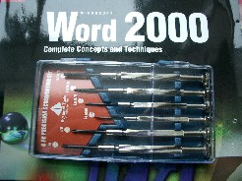

Yours sincerely,

Bill Miller,
VP Sales and Marketing
bmiller@cheaptools.com

This kit has been reserved for you, Mr. LASTNAME!
Don’t miss it – check our site today.

